Vince Pillegi : PhD Candidate
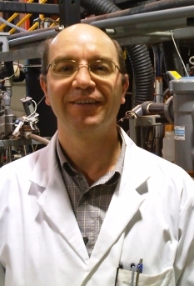
My research includes a comparison of the performance of an anaerobic membrane bioreactor (AnMBR) versus a control flow through anaerobic digester (AD) treating municipal mixed sludge under the mesophilic (35 oC) and psychrophilic (20 oC) conditions at different SRT to HRT ratios at pilot scale. The performance parameters will include volatile solids (VS) destruction, biogas production and chemical oxygen demand (COD) conversion along with membrane flux optimization studies. The investigation will also include the occurrence and concentration changes of selected endocrine disrupting compounds (EDCs) in combination with an assessment of in-vitro yeast bioassay estrogenic (ER) and and androgenic response (AR) of extracts of treated sludges and permeate.

