Muhammad Riaz ul Haq MASc
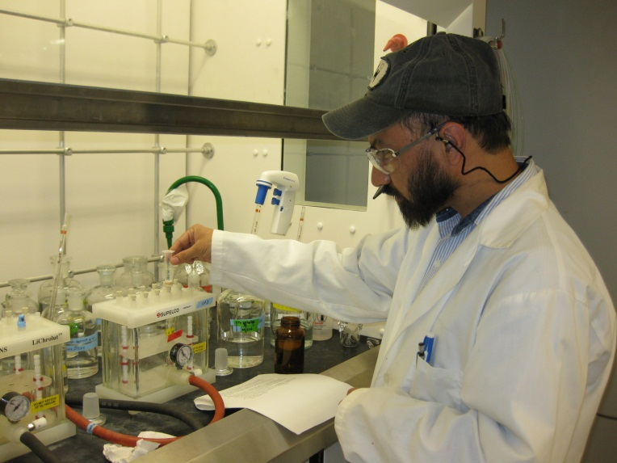
The contribution of the target pharmaceutical compounds by the healthcare facilities (hospitals and long-term-care-homes) to the overall mass loading of wastewater treatment plants (WWTPs) was assessed. In this field study, four healthcare facility effluents and their downstream WWTP influents were monitored for concentration of target compounds and relative contributions by each target facility was investigated.

