Qirong Dong: PhD Candidate
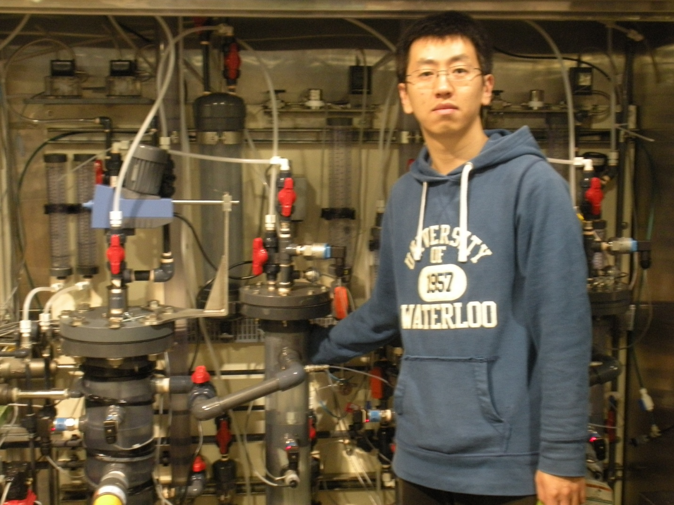
There is an increasing interest in wastewater treatment technologies that are sustainable. The objective of my research is to develop anaerobic membrane bioreactors (AnMBRs) as a sustainable wastewater treatment technology for municipal wastewaters. My research includes bench and pilot scale AnMBRs and focuses on the following aspects: 1) Anaerobic bioprocess optimization by different HRT/SRT combinations; 2) Fouling control methods evaluation (physical and chemical cleaning); 3) Membrane Foulant Analysis in support of fouling control.

