Muyiwa Ogunlaja PhD Candidate

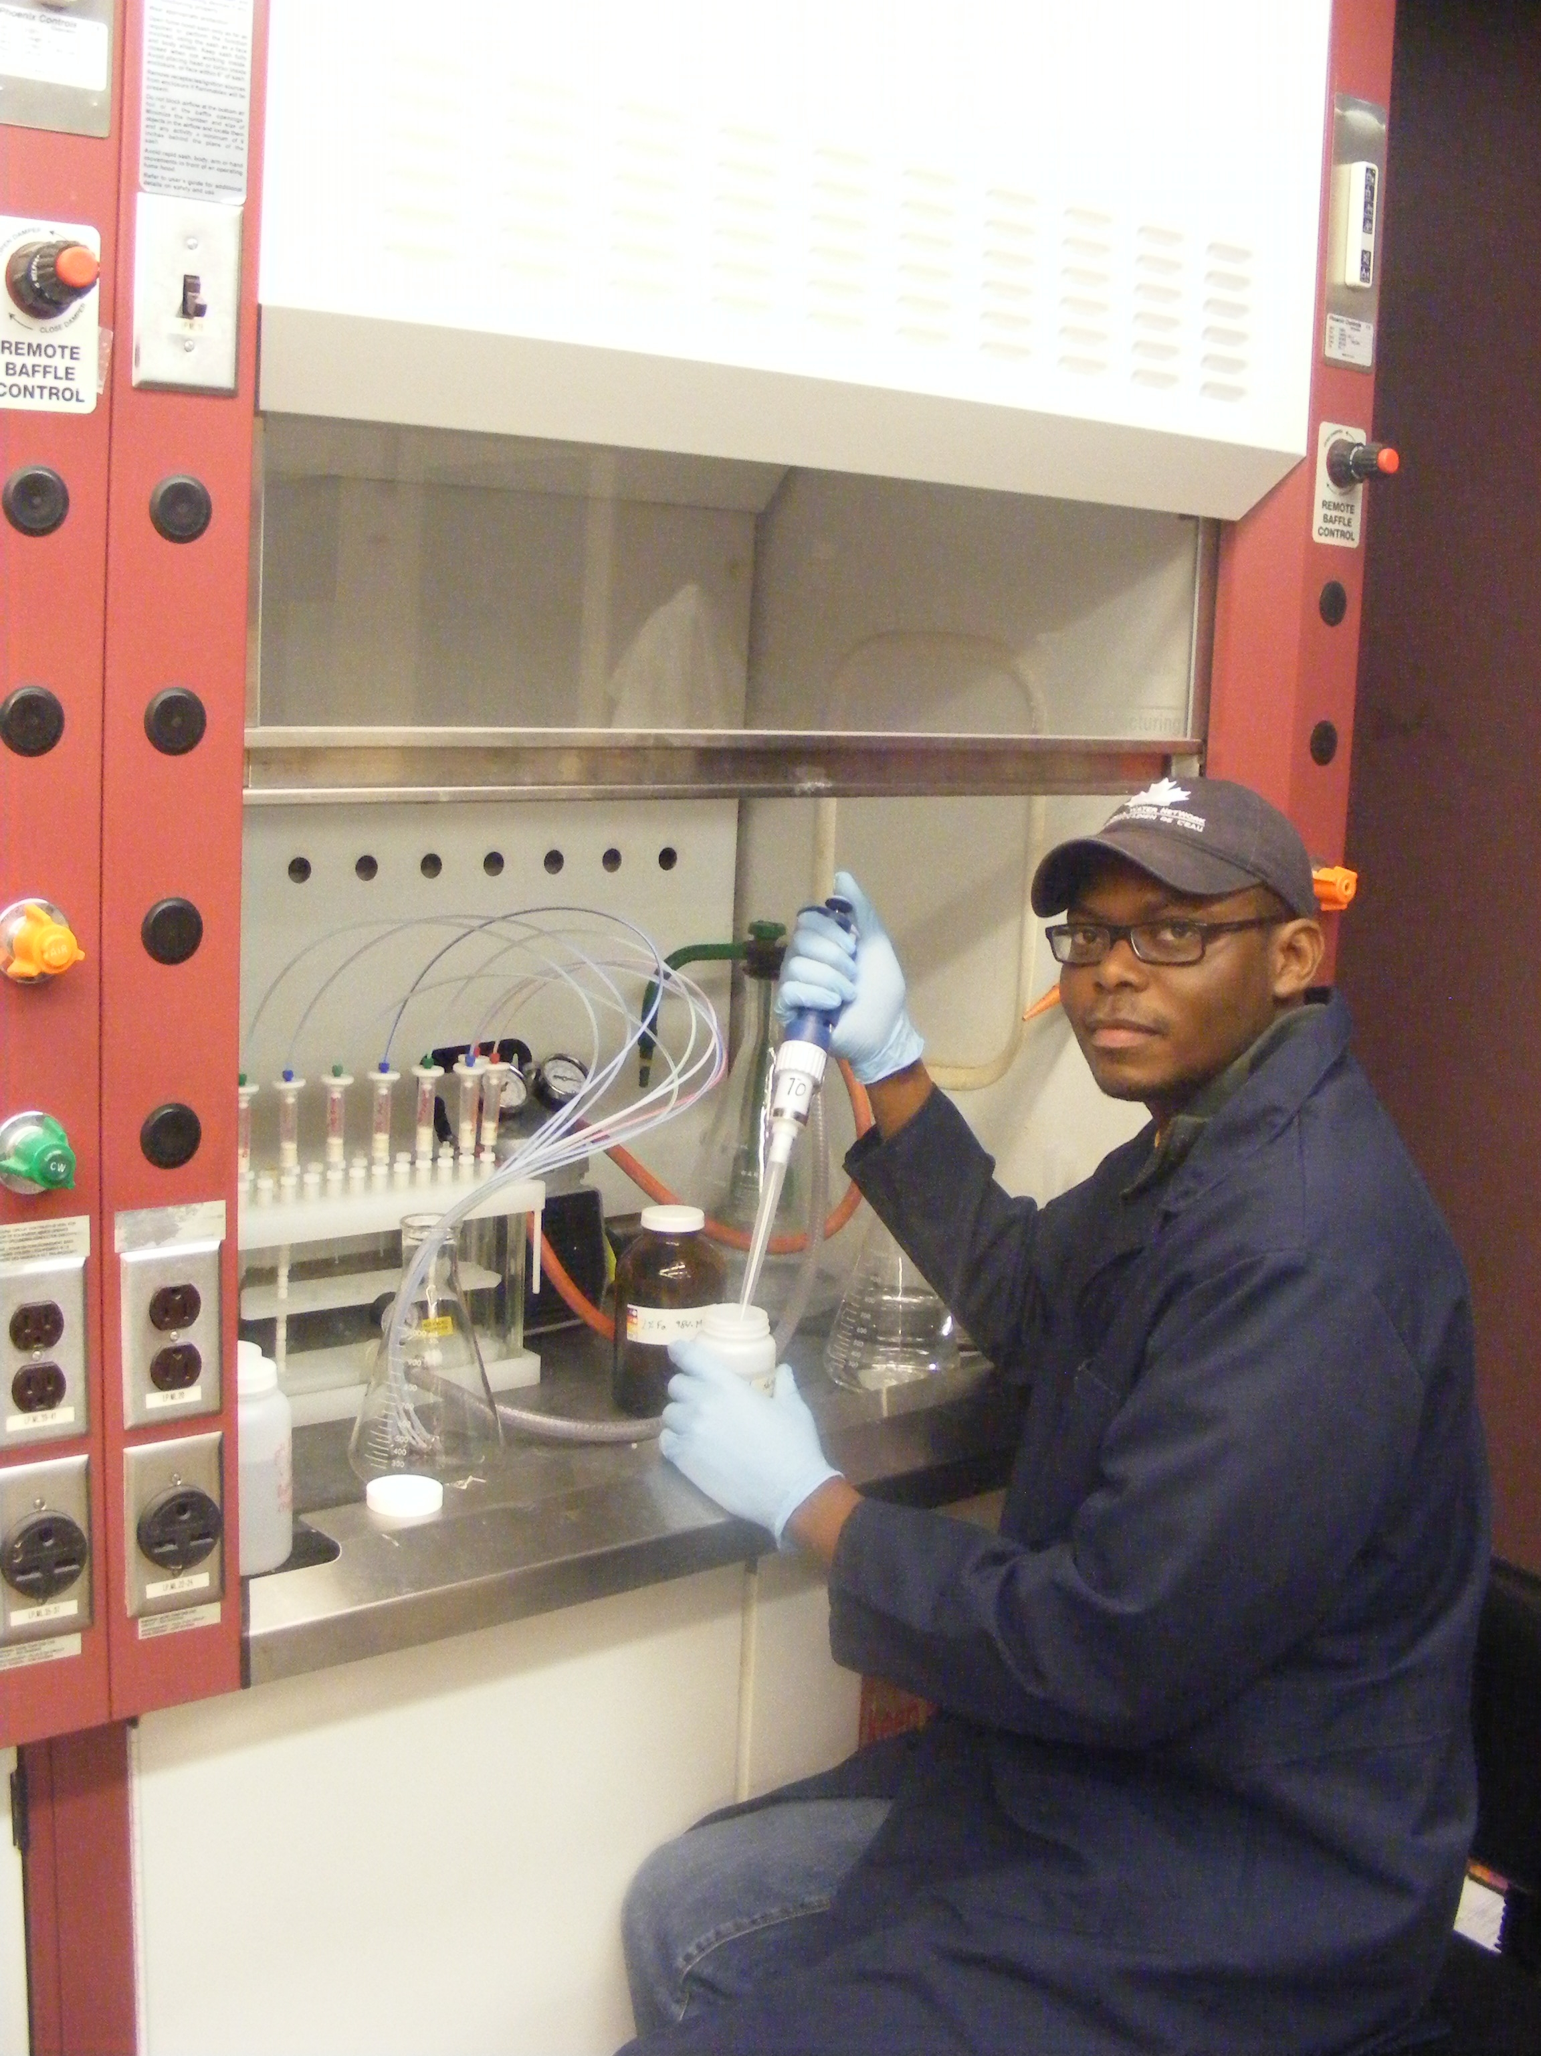
Muyiwa Ogunlaja recently joined the group after receiving his master’s degree in Environmental Engineering from Utah State University and worked briefly with Shell Oil products U.S. His PhD research project focuses on assessing the impact of biological nutrient removal (BNR) process operating and design conditions on effluent quality as measured by aquatic organism responses.

