Mirzaman Zamanzadeh: PhD Candidate
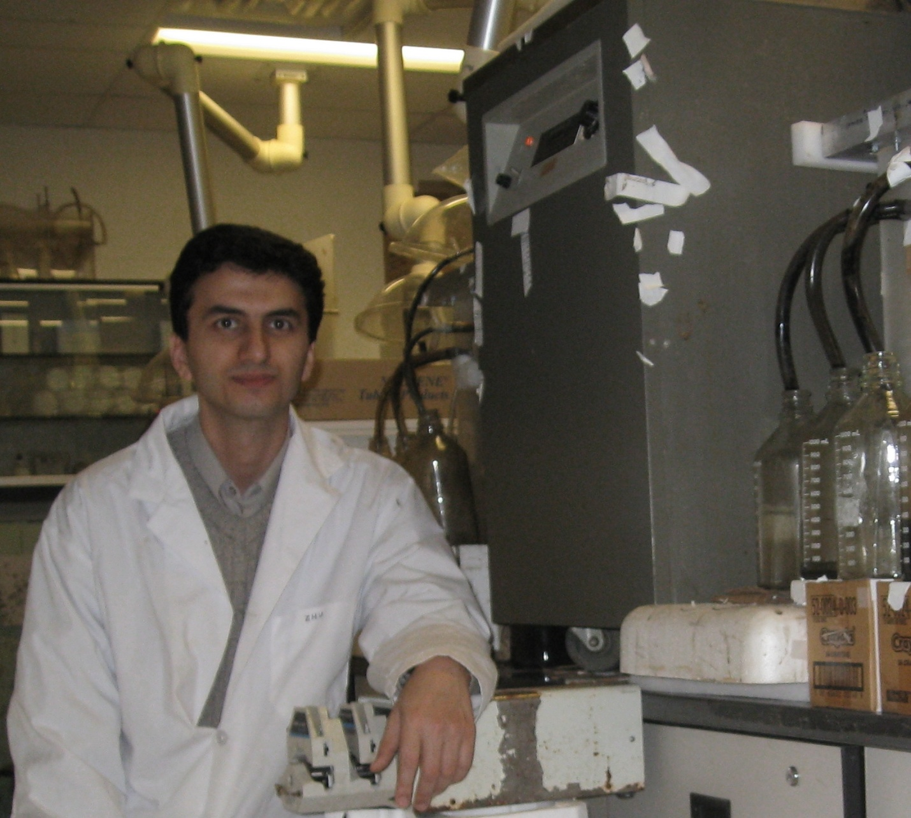
Phased digestion systems is currently of high interest for research. I am working on the impact of phased operation of digesters on the microbial kinetics and ecology using bench-scale digesters. These results can be used for improving modeling of phased digestion systems.

