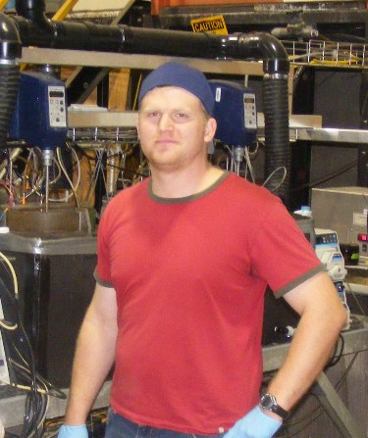
MASc. candidate Kyle Murray is investigating the biodegradation kinetics of pharmaceutical compounds via the integrated fixed film activated sludge (IFAS) process. This experiment aims to investigate any advantages arising from increased biological diversity attributed to this hybridization process, which merges the fixed film and conventional activated sludge process. This research is in response to emerging concerns towards trace organic compounds which demonstrate moderate levels of biodegradability through conventional wastewater treatment processes.

