Gill Staples-Burger MASc Candidate
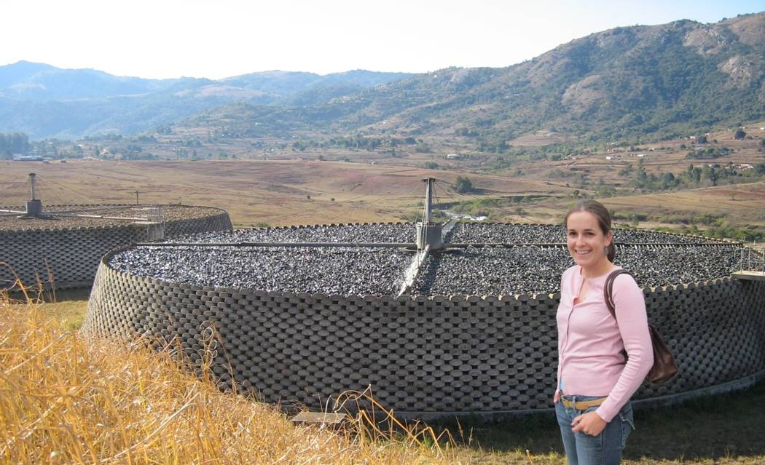
The digestibility of activated sludge may be enhanced by pretreatment technologies and this can be described by changes in COD speciation. The objective of my research is to determine the degree to which each COD component may become biodegradable by using appropriate procedures to measure the various fractions before and after pretreatment. I will pretreat synthetically-generated waste activated sludge in a high temperature and pressure bench-scale reactor and use my results to develop a pretreatment model that can be implemented into BioWin, a wastewater treatment plant simulator, to investigate the effects of pretreatment on the overall process.

