Daniela Conidi: Doctoral Candidate
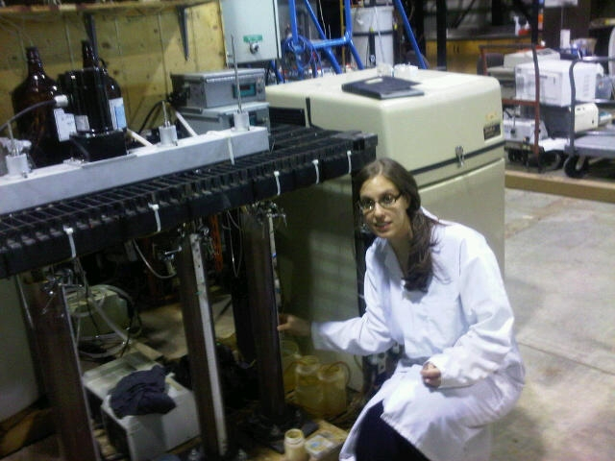
Conducting bench and pilot scale research on phosphate uptake in co-precipitation systems targeting low phosphate concentrations. Research includes modelling and characterization of kinetics and bioavailability of phosphate at ultra low concentrations.

