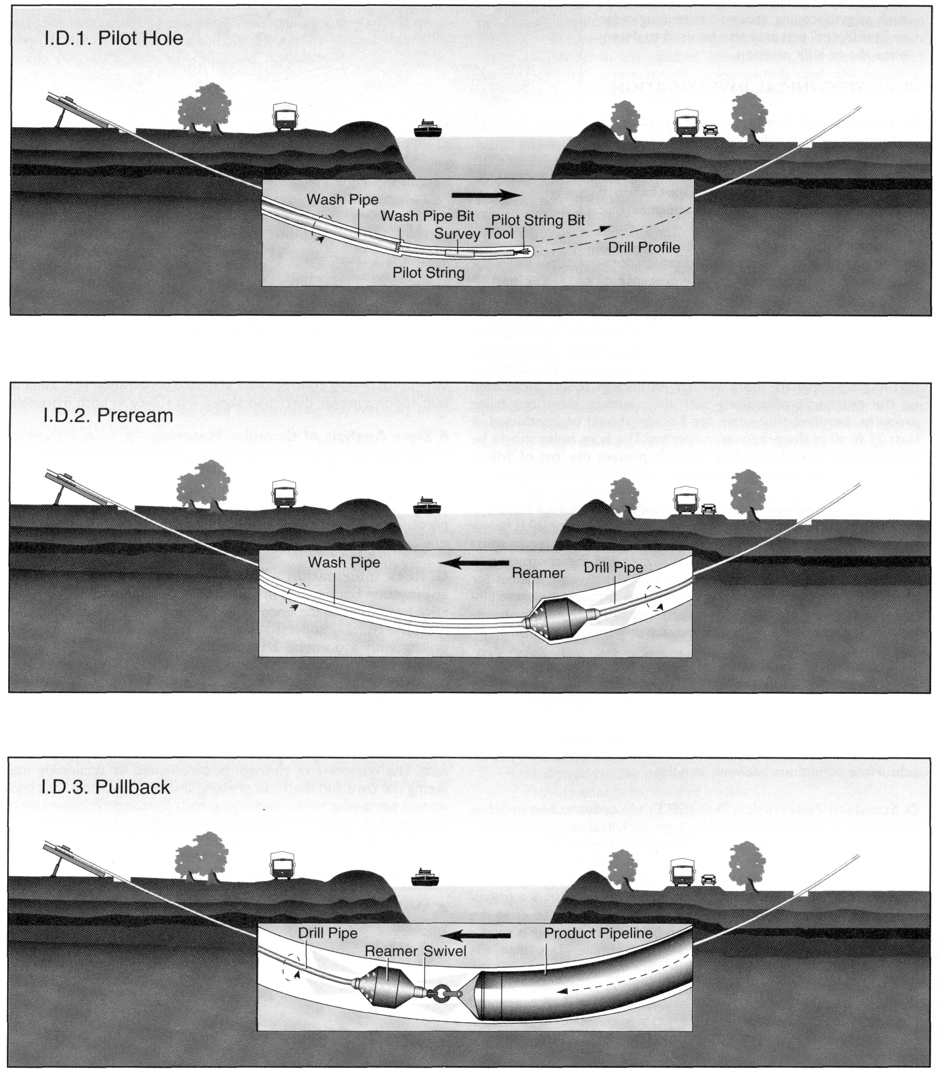
Figure 2 Three stages of HDD pipe installation.
(Directional Crossing Contractors Association, 1998)
The research team for this project consists of Drs Knight and Polak, faculty members in the Department of Civil Engineering at the University of Waterloo, and Marc Gelinas, a research assistance for the Centre for the Advancement of Trenchless Technology (CATT) and MASc. and PhD candidates. Graduate students and the purchase of specialized testing equipment are funded in part by NSERC, IRAP, ESTAC, CFI, ORDCF and inkind and cash contributions from industrial partners.

Quality assurance and assessment of underground infrastructure using non-destructive testing methods

Pipe re-lining over the past 10 years has become a cost-effective trenchless method for the rehabilitation of deterioration under ground infrastructure such as water and sewer distribution systems. The pulling of a video camera though ground infrastructure is the currently the most common method for accessing the pipe state of deterioration and the development of a long-term maintenance and repair programs. Often the quality of the video data is poor and difficult to interpret due to formation of residues and deposits on the inside to the pipe and the quality of video data.

Currently research is underway to investigate the development of a non-destructive testing tool that will: 1) access the state of deterioration of a pipe, 2) condition of soil surrounding the outside of the pipe, and 3) access the quality of pipe rehabilitation.

The research team for this project consists of Drs. Knight and Cascante, faculty members in the Department of Civil Engineering at the University of Waterloo, and MASc. candidates. Graduate students and the purchase of specialized testing equipment are funded in part by NSERC.

Multiple fluid flow in porous media research projects

Fluid Flow through Unsaturated Soil with Geotextiles

A geotextile is a planar permeable polymeric textile material used in contact with soil, rock or any other material. During the past 15 years, the use of geotextiles in environmental, geotechnical, and transportation engineering and related construction activities has been phenomenal. It is estimated that the North American geotextile industry has grown to exceed 1.6 billion dollars annually at an annual growth rate of 20 percent. The primary design characteristics of geotextiles are soil separation, soil reinforcement, filtration, and drainage. Many design applications have geotextiles placed above the groundwater table where soil and geotextile pores are filled with water and air. Thus, unsaturated fluid flow theory flow will dominate. Present design methods assume geotextile pores are only filled with water and saturated flow theory is valid. If geotextiles are to be installed in unsaturated soil, an understanding of fluid flow through unsaturated geotextile is essential. Presently, unsaturated data for geotextiles are not available in the literature. The proposed projects will provide theoretical and practical insights into how fluids flow through geotextiles; methods to measure geotextiles unsaturated parameters; and, unsaturated characteristic data sets for geotextiles. These data are required to perform design analysis. The research will consist of a laboratory program with two main themes. The first is to develop methods to measure unsaturated geotextile parameters and the second is to determine the impact geotextiles have on fluid flow in unsaturated soil. These themes will be addressed in three research projects: 1) measurement of characteristic curves of geotextiles, 2) measurement of hydraulic conductivity of unsaturated geotextiles, and 3) centrifuge soil column experiments. It is anticipated that this research will advance the theory of fluid flow through geotextiles and present findings that will aid a practitioner in designing better soil structures.

The research team for this project consists of Dr. Knight, a faculty member in the Department of Civil Engineering at the University of Waterloo and MASc. candidates. Graduate students and the purchase of specialized testing equipment are funded in part by NSERC and a research award received from the University of Waterloo.

Hydraulic conductivity measurement of frozen sands

Contaminants have been released into the subsurface due to accidental releases, leaking underground storage tanks and containment facilities. Most of these contaminant releases occur above the groundwater table and subsurface soils whose voids are filled with air and water- unsaturated soil. They also can occur during the winter period when the ground is seasonally frozen or in areas where the ground is permanently frozen – a common occurrence in northern climates. Many numerical models have been developed to simulate how contaminants flow through water unsaturated and saturated subsurface soils. However, limited research exists that describes how contaminants flow through frozen unsaturated subsurface soils. The objectives of this research program are two fold. First is to develop frozen soil hydraulic conductivity curves that can be incorporated into the contaminant numerical simulation models. The second is to increase advance the theory of how fluids flow through frozen soil. The research objectives will be accomplished by performing a series of laboratory experiments that investigates the impact of temperature and the degree of water saturation on frozen soil hydraulic conductivity.

The research team for this project consists of Drs Knight and Sykes, faculty members in the Department of Civil Engineering at the University of Waterloo, and a MASc. candidate. Graduate students and the purchase of specialized testing equipment are funded in part by NSERC.

Hydraulic conductivity measurement of contaminant barriers using a geotechnical centrifuge

The accepted method for the determination of the hydraulic conductivity of landfill and storage lagoon barriers is the falling head or constant head test completed on soil samples saturated in a triaxial cell. Difficulties associated with the test method are two fold. The first is that test samples are subjected to unrealistic stress conditions (heads) that are not representative of the field conditions so that sufficient quantity of flow can be obtained from a sample to allow for an accurate estimate of the soil hydraulic conductivity. The second is the long and complicated testing procedure for low hydraulic conductivity materials (1x10⁻⁸ cm/s). Typically a hydraulic conductivity test takes at least seven days to complete.

Dr. Robert Mitchell, (Queen’s University in Kingston, Ontario), proposed the use of a geotechnical centrifuge for the measurement of low hydraulic conductivity soil. The advantages of this method for the measurement of low hydraulic conductivity soils are: 1) testing of soil under realistic field stress conditions; 2) shorting of the testing period to hours (compared to days); and 3) ability to test multiple samples in the field during barrier construction.

This research program will continue the validation of centrifuge derived hydraulic conductivity measurements by comparing the results from the centrifuge to the triaxial apparatus for a variety of soil types. This research is anticipated to led to the accepted use of a mobile (field) geotechnical centrifuge as a quality control tool during contaminant barrier construction. All laboratory and centrifuge testing will be completed in the University of Waterloo soil mechanics laboratory and the newly constructed 1.8 metre diameter geotechnical centrifuge, respectively.

The research team for this project consists of Dr. Knight, a faculty member in the Department of Civil Engineering at the University of Waterloo, and MASc. candidates. Graduate students and the purchase of specialized testing equipment are funded in part by NSERC.

