Stacking Blocks
Many natural and human-built structures can be considered objects stacked one on top of another, and we can learn a great deal by studying such structures.
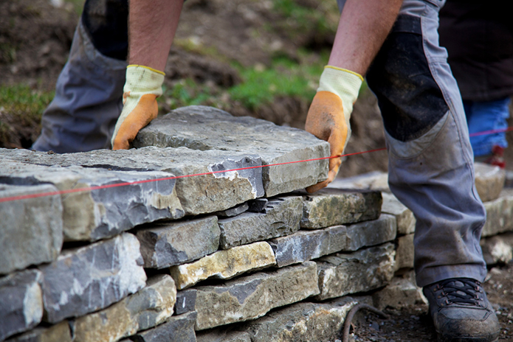
- Form groups of 3 or 4 members.

- Assign one person to record what you do and what you learn in this activity. Chose that person well, as your grade will depend, in part, on what they write. They can start on Step 3, below, now. Have another person collect the materials indicated in Step 4.

- At the top of a fresh sheet of paper that you will shortly hand in, record the name of this activity, and the date. Section 7.2.4 on page 7-5 shows the general structure of a typical submission. Then list the names and IDs of all group members. Record additional entries for each numbered step in this activity, as appropriate.

Your recorded notes will be submitted at the end of the class period. You need not complete all Steps in the activity to receive full marks. Instead, strive for understanding, and have fun.

- Obtain one set of 4 blocks, a ruler and a foam sheet for your group.

“Play is the highest form of research.” Albert Einstein

- Your goal is to stack the blocks in such a way as to maximize the distance by which the top block overhangs the lowest block (the dimension d in the drawing below). It is recommended that you proceed as described in the steps that follow.
d

- Play with the blocks for a minute or two in order to understand how stacked blocks behave.

- What forces act on your blocks, and what is their source? Record your thoughts.
- Then, without using the blocks as an aid, propose three or more possible ways to stack the blocks so as to maximize the offset of the top block. Write down your ideas and label the designs as A, B, C, etc. The blocks need not remain oriented horizontally nor do they need to remain in a single plane. Use your imagination. Record your designs, even ones you think will not be your best strategy.

- Now choose one or two of your designs (identify their letter(s) from Step 8) and build them, fine tuning them so as to produce maximum overhang. Can you feel the forces in the blocks? For at least one design, record how you optimized it and what you learned. What are the key features that make it effective?

- Measure and record the greatest overhang (d, in centimetres) you were able to produce.

- SUBMIT YOUR REPORT BEFORE LEAVING THE CLASSROOM.

Bring a 12” ruler, an eraser and a stack of quarters (12 or more) to the next several classes and tutorials.

