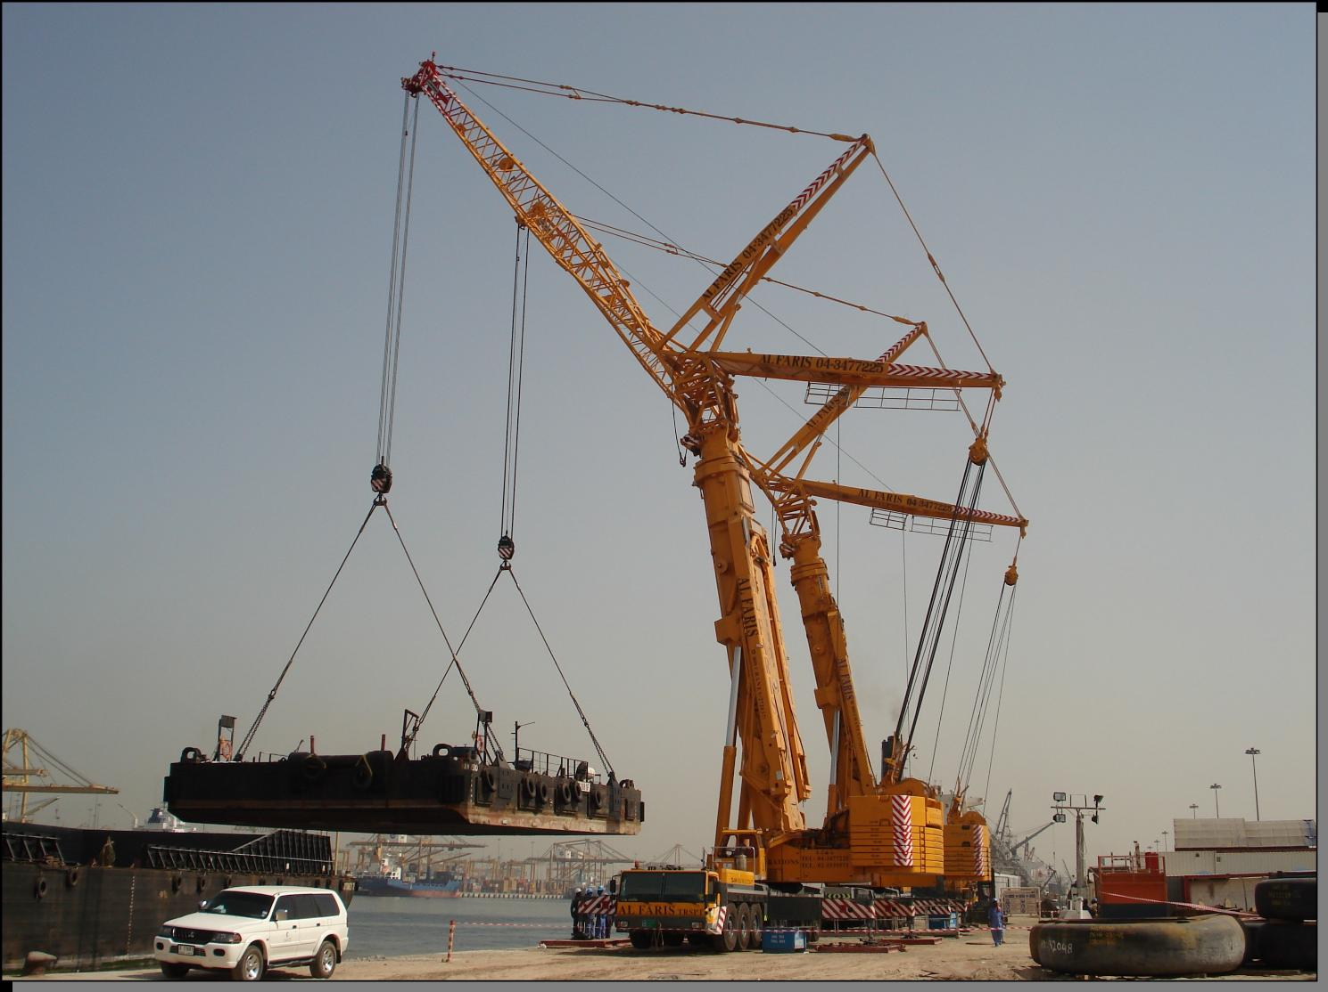
Forces at a Point
http://www.alfarisuae.com/?m=201004

Objectives:
To discover the relationship that must exist between forces acting at a point in order for that point to be in equilibrium. In this activity, a “point” is approximated by a small ring.
To collect the data, images or videos needed to produce the assigned deliverable (report, photo essay or video) associated with this activity.

Apparatus:
From an “Equilibrium” kit and the classroom trolley, put together the following:
Quantity | Item(s)
1 | Metal ring (Circular carabiner)
4 | Spring scales
1 | Ruler
2 | Large (24” x 35½”) sheets of paper

Spring scale
Ring

Note that the scales used in this project were originally designed for weighing fish and so are calibrated in units of kg and lb. The scales actually report kgf and lbf, the gravitational force that would act on fish or other weighed objects having corresponding masses in kg and lbm. Since we are using the scales to measure forces, it would have been more convenient for us if they had been calibrated in units of N.
Note, also, that the scales have a maximum-load indicator that can be reset to zero, and that it can be quite useful for measuring applied loads.
Load and max indicator stay together as load increases
Load and max indicator separate when load increases
Load indicator
Maximum load indicator
DO NOT ALLOW THE FORCE IN ANY OF THE SPRING SCALES TO EXCEED 5kg.

Recommended Procedure:
- How can you convert measurements in kg (actually kgf) to N? Convert a spring scale reading of 5kg to N.
- Sketch one of the 2 cranes shown in the photo on the first page of this activity along with the loading sling and load, and identify 3 places where multiple cables and/or other structural members connect essentially at a point.
- Attach one spring scale to the ring. The ring is a carabiner, and is equipped with a spring-loaded segment that hinges inwards so that an object with a hole can be attached to it. Can you apply a tension of 3 kgf to the ring using that spring scale, and while applying no other forces to the ring, have it remain stationary? Why or why not? The hypothesis being tested in this part of the activity is “that a ‘point’ can be in equilibrium under the action of a single, non-zero force.” Does the hypothesis turn out to be true or false? Can you relate what you observe to one of Newton’s Laws?

- Attach a second spring scale to the ring. Place the apparatus over one of the large pieces of paper. Place the letter corresponding to this activity part on the sheet of paper and draw a box around it. Slowly increase the tension in the first scale (the master scale) to 2 kgf while at the same time applying whatever load is necessary in the second (slave) scale to stop the ring from moving. Note that the applied forces (the maximum load indicators may be useful for doing so). Before releasing the loads, trace around the outside of the ring and trace along the sides of the load scale rods (see figure below). Record the magnitudes of the applied loads on your drawing.
2.0 kgf
1.9 kgf

- Now use the ruler to draw straight lines along the original bar locations, making the length of those lines proportional to the applied loads. Put an arrow in the direction in which the force pulled. What hypothesis is being tested in this part of the activity? What do you notice about the magnitude of the force in the second scale? What do you notice about the alignment and direction of the force in the second scale? Note that there is a certain amount of error in the force values that you measure.
2.0 kgf
1.9 kgf

- Repeat part (D) of the experiment with a tension of 4 kgf in the “master” scale. You might want to use the back of your first sheet of paper for this activity. What is the force in the second spring? Can you draw any tentative conclusions? Can you relate this finding to one of Newton’s Laws?

- Now attach a third scale to the ring. Place the first two scales at 90° to each other, as shown below, and the third one at θ=45° to the first ones, as shown. Slowly increase the load on the angled (master) scale to 4 kgf. How much load do you need to apply to the other two (slave) scales to keep the ring from moving? Trace the directions of the applied loads on a sheet of paper by tracing along the sides of the spring scale rods while they are under load. Then draw arrows along those directions proportional to their corresponding loads, as in the second figure, below.
θ

4.0 kgf
3.5 kgf
2.1 kgf
If you now draw those arrows head to tail, as shown below (their order does not matter), what do you notice?
or

- If you have studied vectors, to what mathematical operation does putting vectors head to tail correspond? What does your finding in part (F) mean in terms of the force vectors acting on the ring? If you have not studied vectors, just report that you have not as your answer for this part of the activity.
- Select two of the three force values and calculate their ratios, dividing smaller values by larger ones. Do the same for all three possible force pairings. Calculate the sine, cosine, tangent and cotangent of the angle you used (e.g., θ=45°). Compare the trigonometric function values with the force ratios you calculated. Do you notice any correlations? If so, describe them.
- Repeat F and G for an angle of θ=30°.
- Repeat F and G with the three scales at arbitrary angles of your choice (you might need to use the back of one of the pieces of paper). What do you notice? Can you change the magnitude or direction of the force in one scale without changing either the magnitudes or directions of the forces in the other scales? What does your finding tell you? Can you relate this finding to the photograph at the beginning of this activity and specifically to the points you identified in it? What happens if you try to experimentally duplicate the angles associated with one of the points in the photo where 3 cables meet as you pull on the spring scales? Could you use your experiment to determine the ratios of the forces in the cables? So, what kind of force information might you be able to infer from a photograph?
- Repeat F with four scales attached and arbitrary angles of your choice. Remember not to apply any loads larger than 5kgf.
- Put together a paragraph, photo or short piece of video footage, as appropriate, to summarize the main things that you learned.
- If you have extra time, you might want to do some of the steps in Activity A1.2 – Multi-force Body.

Wrapping up:
- Organize and place the apparatus back in the container in which it came.
- Return the apparatus to its designated location.
- Prepare and submit the specified deliverable for this activity by the stated deadline. Include your tracings with your submission.

