Tanks (Silos) and Culverts (Tunnels)

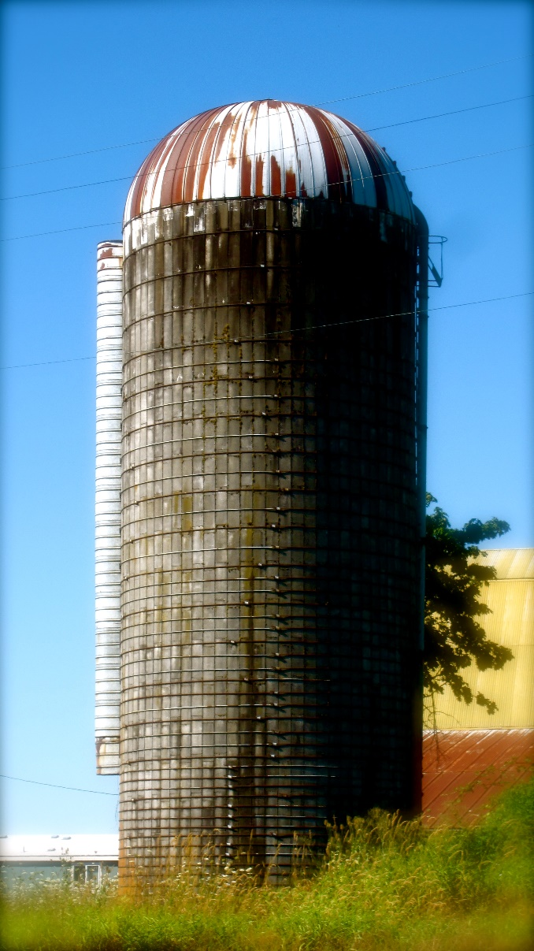 | 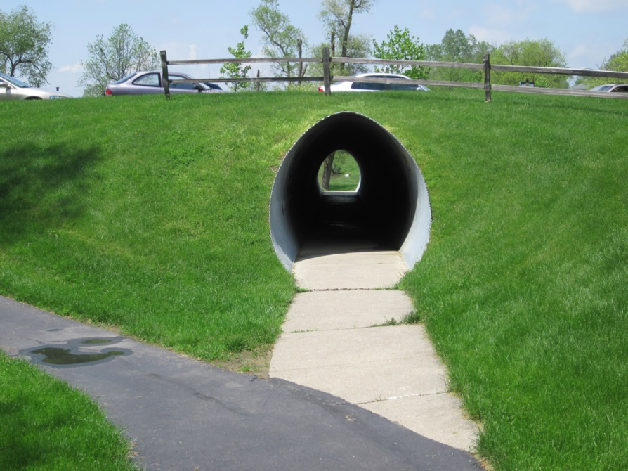  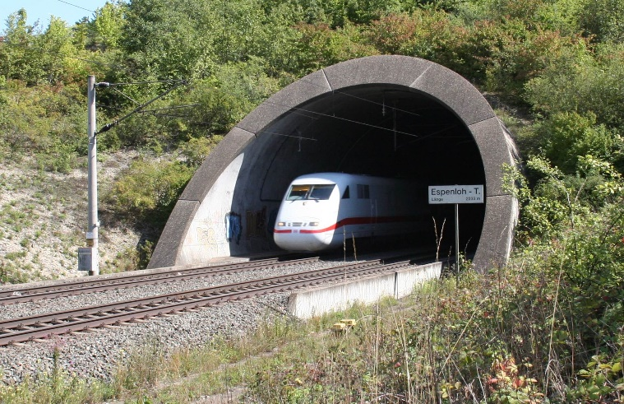
https://dacarc.wordpress.com/2010/11/01/dissolute-beauty/ | http://ceephotos.karcor.com/tag/tunnel/  https://commons.wikimedia.org/wiki/File:Espenloh-Tunnel.jpg

Objectives:
To discover, from a structural point of view, how tanks (silos) and culverts (tunnels) work.
To collect the data, images or videos needed to produce the assigned deliverable (report, photo essay or video) associated with this activity.

Apparatus:
From a “Soil and Water” kit and the classroom trolley, put together the following:
Quantity | Item(s)
1 | Plexiglas box
1 | Marbles in a storage container
3 | Black, curved tank /silo walls
1 | Grey circular disk
6 | Rubber bands
2 | File folders
1 | Pair of scissors
1 | Roll of tape
1 | Ruler

Tank (Silo) – Recommended Procedure:
Please ensure that the marbles you work with do not “escape.” Any marbles that “make a run for it” should be captured promptly.
- Empty all items out of the Plexiglas box. Put the grey circular disk in the bottom of the box, near its center. Assemble the three curved black tank walls together to make a circular vertical tank or silo like in the image on the previous page (but without a roof).
- Have one group member hold the three curved wall segments together by hand while other group members take handfuls of marbles from the marble container and fill the silo. One group member may want to hold their hands in the shape of a funnel to aid filling. Are the needed restraining forces largest at the top, or at the bottom, or are the top and bottom forces the same? If you think that different restraining forces must be applied at the top and bottom, try to estimate their ratio.
- Have all group members hold the silo together as the other members fill it. Do all of your group members agree about the pattern of the forces needed to hold the silo together? It is not necessary for them to agree. Return the marbles their storage container.
- Now, place rubber bands around the silo wall segments to hold them together, and fill the silo. What is the minimum number of strategically-placed rubber bands you need to keep the silo from “leaking” marbles? Where should those rubber bands be placed, and why? Note that each rubber band should pass around the silo only once – doubling wrapping of the rubber bands is not allowed.
- Do you notice any correlation between your optimal placement of the rubber bands in (D) and the placement of the bands around the silo shown on the previous page? Speculate on why the band are placed as they are on the real silo. Return the marbles their storage container.

- If you purposely allow the silo walls to expand and then try to push them back together, what do you notice? That is how does the expansive force the marbles exert on the wall differ from the force it exerts when resisting compression? Can you estimate this ratio? What does this part of the experiment tell you about the behavior of granular media (such as marbles, gravel, soil or grain)? Can you speculate on why this behavior occurs? If you wet or oiled the marbles, do you think that what you would observe would change?
- If you hold the silo just tight enough that it does not expand when full – either by hand or using the rubber bands. – and then drop one or two more marbles in, what do you notice? What does this experiment tell you about the behavior of granular media?
- Do you think that fluid in a tank would generate similar forces? In what ways do you think the behavior would be similar to that of the marbles, and in what ways different?
- Is the wall of a typical pipe or tank under tension of compression? How do pipes and tanks tend to fail? Do any tears that develop tend to run along the pipe or tank length or around its circumference? If you look on the internet you might be able to find photographs that support your claim.
- Frozen water pipes often fail. Do you know how and why?

Culvert/Tunnel – Recommended Procedure:
- Cut a piece of file-folder cardboard so that it is ¼” narrower than the inside width of the Plexiglas box. Now form all or part of that trimmed cardboard into a culvert shape of your choice, using tape as needed. You might want to make the width and height of your culvert in the range 1½ to 3” inches. You may want to overlap the cardboard at any joints and tape both the inside and outside of the joint. If you wish, you can tape over one end of your culvert so as to help form it into the shape you desire.
- Place the culvert in the bottom of the box and begin to “backfill” the culvert with marbles (a surrogate for gravel and soil). Describe 2 or 3 ways in which your culvert can fail. You might backfill according to different patterns in order to produce different modes of failure. You might want to use your hand to help hold your culvert in its intended shape and/or position for some (but not all) of your tests.
If you find yourself short of marbles, place the retaining walls vertically at the ends of the box in such a way that they fill up the ends of the box, and back them up with wads of paper.
Retaining walls
Paper
wads
Culvert
Marbles

- Make a culvert or tunnel of another design and repeat (L). You might change the size, shape or number of layers of material in your culvert. If your first design had curved surfaces, you might chose a design that has one or more flat sides. Report any new modes of failure and any modes that are now avoided. The goal is not necessarily to avoid failure, but to learn about how culverts and tunnels can fail.
- Write a few summary comments about how you think culverts and tunnels work. What kinds of loads does the wall of the culvert or tunnel need to resist? Tension? Compression? Bending? Explain the basis for your answers, where possible.
- What is similar and what is different about how tanks (pipes) and culverts (tunnels) work?
- The photographs on the right side of the first page of this activity show two tunnel designs. Comment on them with respect to load carrying and possible construction methods.

Wrapping up:
- Organize and place the apparatus back in the container(s) in which it came.
- Return the apparatus to its designated location.
- Prepare and submit the specified deliverable for this activity by the stated deadline.

