**HAS NO HIDDEN TEXT**

## Suspension Bridge

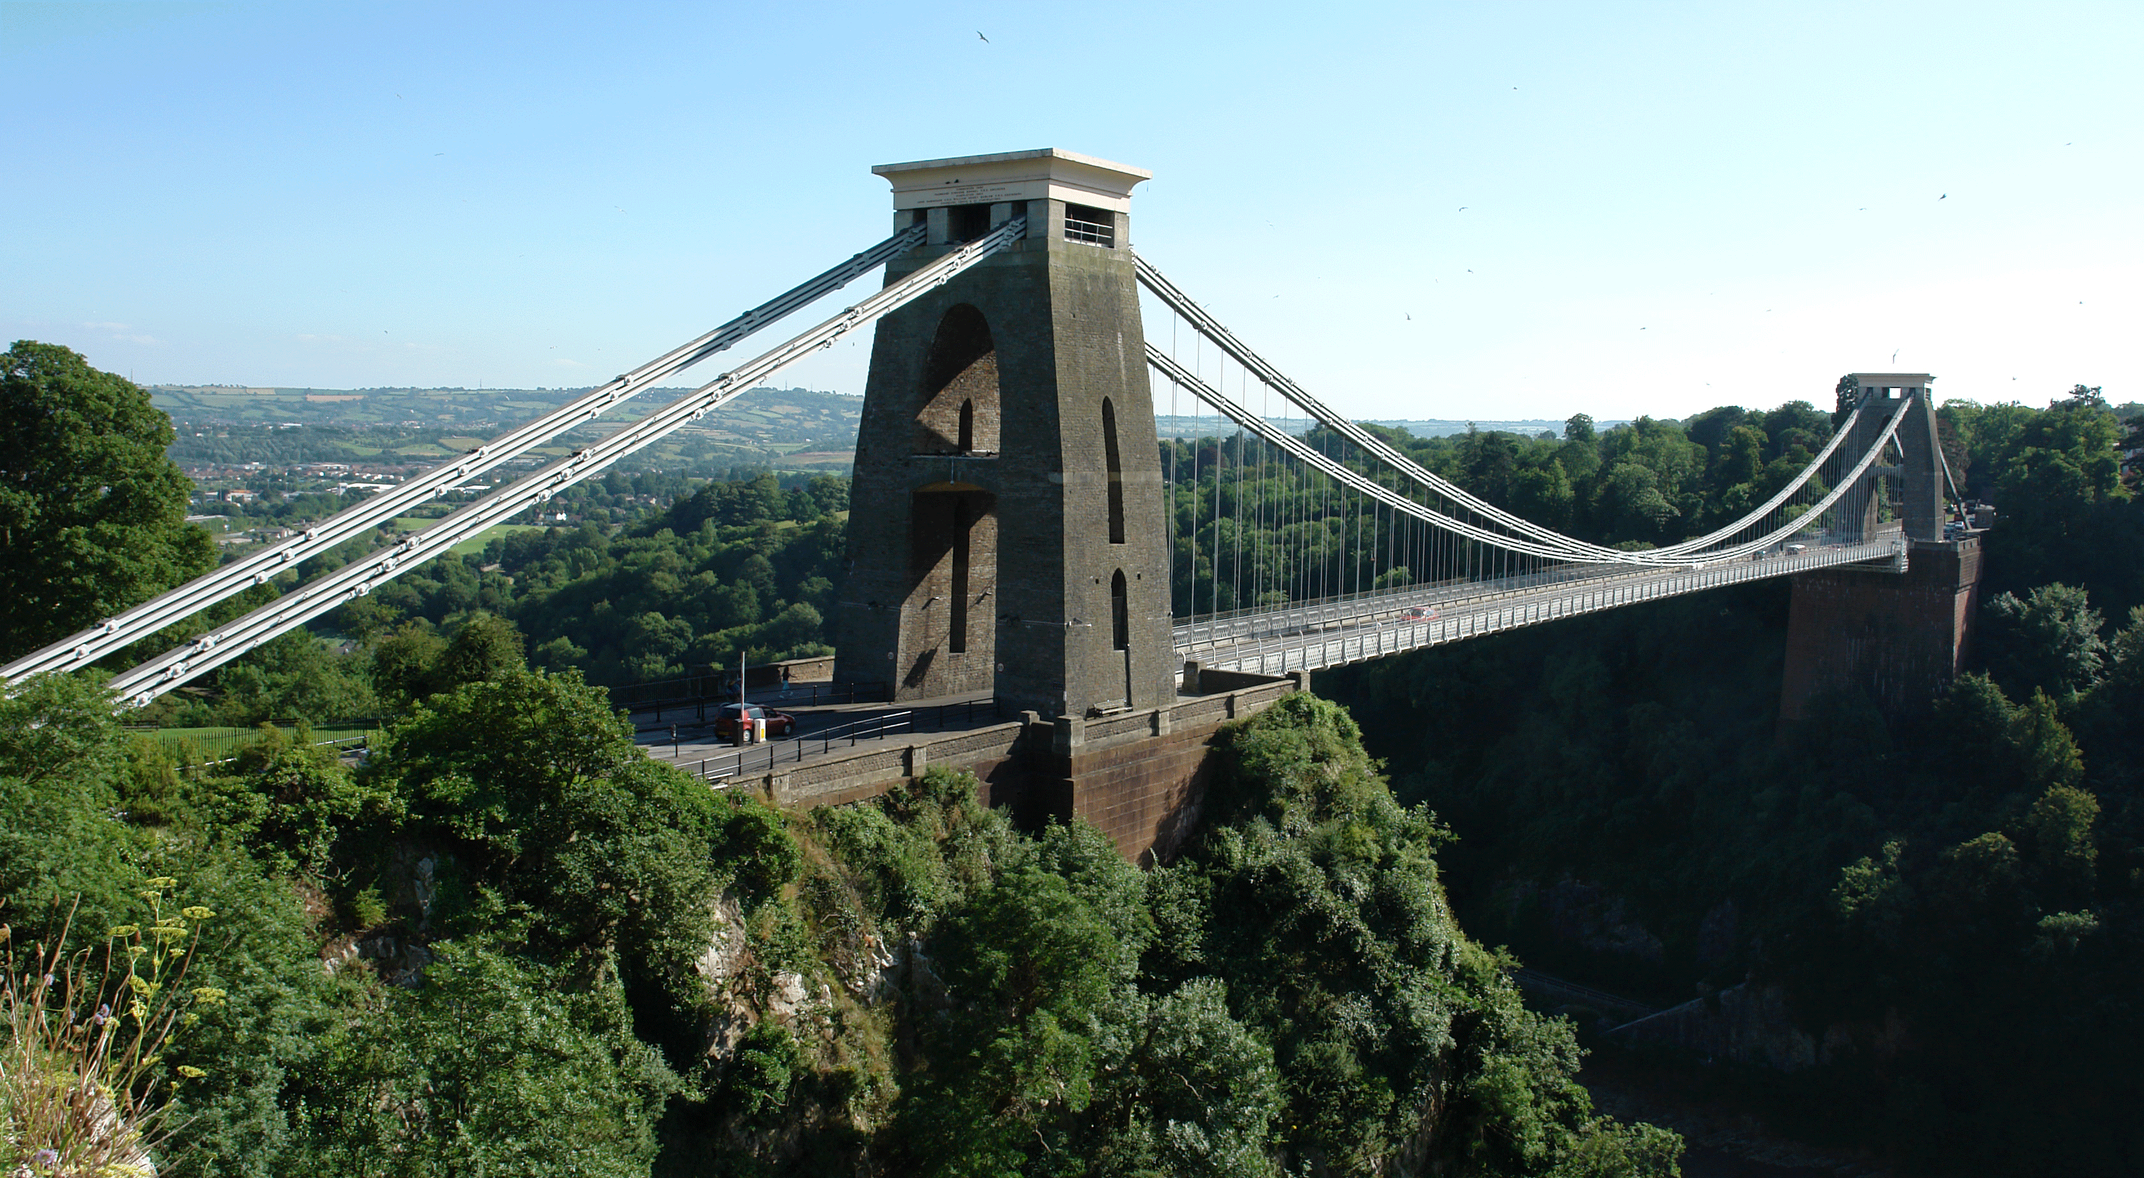

<http://www.flintneill.com/clifton-suspension-bridge/>

#### Objectives:

To learn how a suspension bridge works.

To think about the challenges associated with construction of a suspension bridge and to propose possible solutions to some of these challenges.

To collect the data, images or videos needed to produce the assigned deliverable (report, photo essay or video) associated with this activity.

#### Apparatus:

Lay out the following items from a “Suspension Bridge” kit:

|  |  |
| --- | --- |
| Quantity | Item(s) |
| 2 | Bases with attached piers and towers |
| 7 | Short plywood deck section with side pins (no indicative markings) |
| 3 | Short plywood deck section with no side pins (red dot on underside) |
| 1 | Long plywood deck section (green dot on underside) |
| 2 | Thin plywood deck sections (blue dot on underside) |
| 2 | Chains |
| 2 | Rubber mats |
| 1 | Ruler |

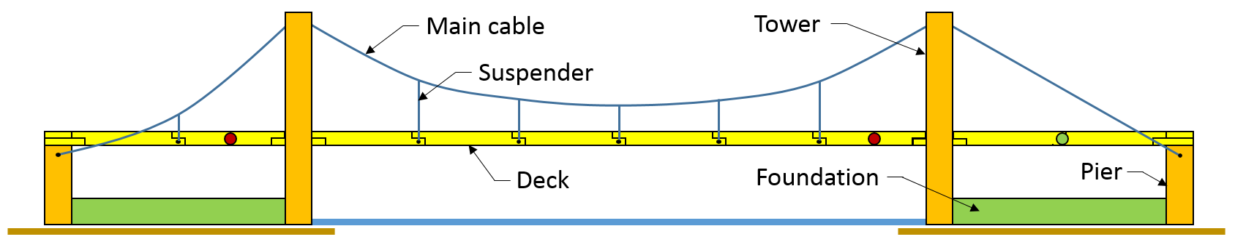

#### Recommended Procedure:

1. Place the mats and bases as shown in the figure below. Note that the supplied ruler may not be as long as some of the distances you will need to measure. That situation exists on purpose, so you can think about how to measure long distances. Can you figure out why the mats are necessary? Measure the spacing of the bases carefully. Imagine that you are building a real bridge and cannot move the ends once they are built in place.

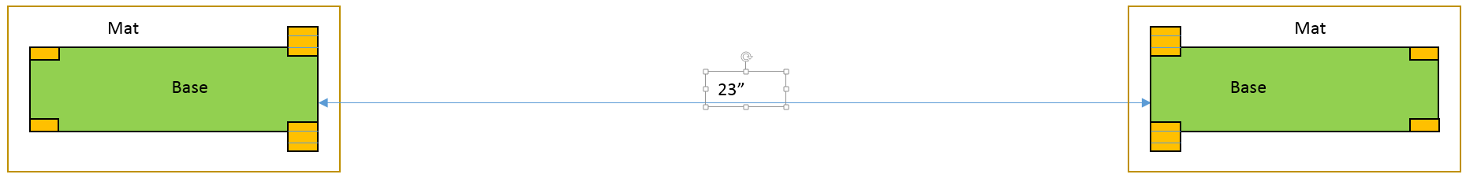

1. The towers of real suspension bridges can be as much as 1km apart. How can their positions be established with the high accuracy that is needed to ensure that all components will fit properly as the bridge is assembled? Propose several measurement methods. If possible, estimate the expected accuracies of each method. For purposes of this exercise, assume that the ends of the bridge are separated by a body of water (so that ground based way points cannot be established along a straight line between the ends of the bridge).
2. Think about the order in which you will build the rest of the bridge and record your thoughts. Remember that the water may be deep, the current strong and the distance to the bridge deck 10m or more. For purposes of this exercise, you choose and record the conditions associated with your bridge. Construction options you might consider include barges with cranes and temporary frameworks that sit on the parts of the bridge that have already been constructed.
3. How could you construct/install the main cable? Bear in mind that it could weigh 10 or more tons, and for corrosion protection it must not be allowed to directly contact the salt water below.
4. Now carry out your construction plan. Note any unanticipated difficulties and their solutions. Note that the chains are sized so that you attach the last link of the suspenders to the pins on the side of the deck sections, and the end link of the main chains on the pins at the piers.

If the long deck section (green dot) is used at one of the ends of the bridge (between the tower and pier) as suggested in the drawing on the previous page, then you might want to attach the second or third last link to the pin on that pier. How does this design (a non-suspended approach to the main span) compare to the photo on the first page of this activity?

1. Once your bridge is constructed, think about the loads to which a real suspension bridge would be subjected. Make a list of them. Describe these loads (forces) using the terminology introduced in Chapter 2 of the course notes.
2. Then describe how these loads are carried from one member to the next until they are ultimately transferred to the towers. Be as specific as possible.
3. How large do you think the tension is in the main cables compared to the weight of the supported deck? Can you think of a simple calculation to determine this ratio?
4. What is the purpose of the rubber mats under the support bases? Even if you think that you know the answer to this question, remove one of the mats temporarily and report what happens.
5. Now, pretend that you are driving a heavy truck across the bridge (perhaps simulate this event by walking your fingers along the length of the deck). What do you notice about the roadway?
6. Suspension bridges usually have relatively rigid decks, a situation that you can simulate by placing the two longest pieces of plywood (the ones with the blue dots) along the deck of the main span. What difference does this make to the motions produced should a heavy truck cross the bridge?
7. Summarize 4 to 5 points that you learned about the design, construction and operation of a suspension bridge.

#### Wrapping up:

1. Organize and place the apparatus back in the container in which it came.
2. Return the apparatus to the designated location.
3. Prepare and submit the specified deliverable for this activity by the stated deadline.