How the Beam Bending Spreadsheet Works

# Introduction

The spreadsheet described in this document was designed to parallel a Beam Bending Model in which thin rectangular beams are supported by clamped, simply-supported and free boundary conditions and loaded by weights that essentially produce point loads (Fig. 1.1).

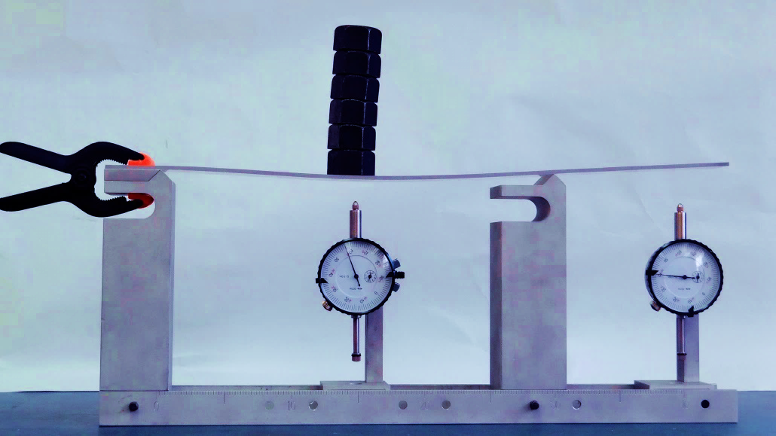

FIGURE 1.1 The beam bending model that inspired this spreadsheet

The model is equipped with dial gauges so that the deflection of arbitrary points, though usually points beneath the applied loads, can be measured. This information can be used by the spreadsheet to calculate the load that had to be applied to the beam to produce the observed deflections, something the students enjoy seeing. Unfortunately, the self-weight of most of the physical beams is of the same order as that of the applied weights, and it contributes meaningfully to the total deflection. If the dial gauge readings before any external loads are applied are subtracted from the corresponding readings after all of the applied loads are in place, the self-weight-induced beam deflection can be effectively removed and the need to position the dial gauges at specific vertical locations, which would otherwise exist, can be eliminated.

# Operation

The spreadsheet can be used in two different ways. If the external loads on the beam are specified, the spreadsheet will calculate the resulting deflections. If, instead, the beam deflections are specified in the spreadsheet (presumably having been measured from the physical apparatus), the spreadsheet will calculate the loads required to produce those deflections (and these calculated loads should essentially match those actually acting on the physical apparatus). It is not necessary to choose which mode is desired, as the calculation engine automatically takes proper account of the nature of the information provided and uses that information to structure the governing equations (as is done in a finite element or structural analysis program).

Note also, that all measurements are in metric units, except that any specified deflections are assumed to be in thousands of an inch (the units of the dial gauges we were able to purchase).

# Mathematical Representation

For simplicity, the mathematical representation of the beam was assumed to consist of three segments that are joined together at four arbitrarily-positioned but sequential junctions A, B, C and D located, respectively, at positions x1, x2, x3 and x4 (Fig. 2.1). All boundary conditions and point loads are assumed to act at these points, and any deflection measurements are made at them, as well.

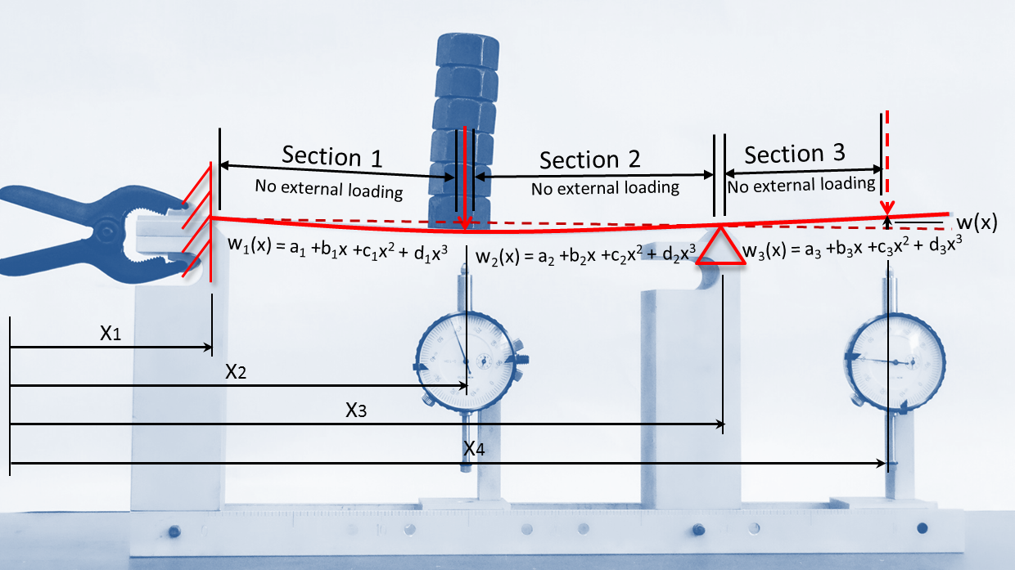

FIGURE 2.1 Mathematical representation of the beam

Because the segments between the junctions carry no load, the transverse load function q(x) along each segment is

|  |  |  |
| --- | --- | --- |
|  | $$q(x)=0$$ | (1) |

and the solution to the classical beam bending equation

|  |  |  |
| --- | --- | --- |
|  | $$\frac{d^{4}w}{dx^{4}}=\frac{q\left(x\right)}{EI}$$ | (2) |

is a cubic deflection function w(x) that can be written as

|  |  |  |
| --- | --- | --- |
|  | $w\left(x\right)=a+bx+cx^{2}+dx^{3}$. | (3) |

As suggested by Fig. 2.1, each of the three beam segments is described by its own cubic and its coefficients are distinguished by subscripts. For reference, a full set of beam plots is given in Fig. 2.4, and the deflection illustrated in the first part of that figure is described by three cubic displacement polynomials – one from A to B, another from B to C, and a final one from C to D.

The plots assume the independent variable x to be positive to the right, and all deflections illustrated herein are assumed to be positive upwards (the usual direction of the y axis). The Properties tab of the spreadsheet, however, allows the user to independently select the positive sense of the deflection, slope, curvature, moment, shear and load (Fig. 2.2), and those preferences are applied just before the Plotting Data table is populated, but not in the Solver step. For the sake of clarity, the default values are used exclusively in the descriptions given here. All three deflection polynomials have a common origin for their independent variable x, as indicated in Fig. 2.1.

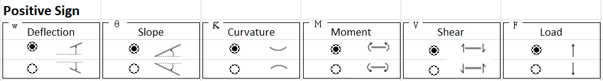

FIGURE 2.2 Positive sign table on spreadsheet

TABLE 2.1 Sign conventions

|  |  |  |  |  |
| --- | --- | --- | --- | --- |
| Quantity | Default positive sense | | Alternate positive sense | |
| Deflection |  | Upwards |  | Downwards |
| Slope |  | Uphill |  | Downhill |
| Curvature |  | Sagging |  | Hogging |
| Moment |  | Sagging |  | Hogging |
| Shear |  | Down on the right |  | Up on the right |
| Load |  | Upwards |  | Downwards |

Figure 2.3 illustrates how a section of a beam that contains no external loading can acquire a cubic shape, confirming the use of cubic polynomials to describe the deflected shape of beam segments that lie between any of the various loads or supports.

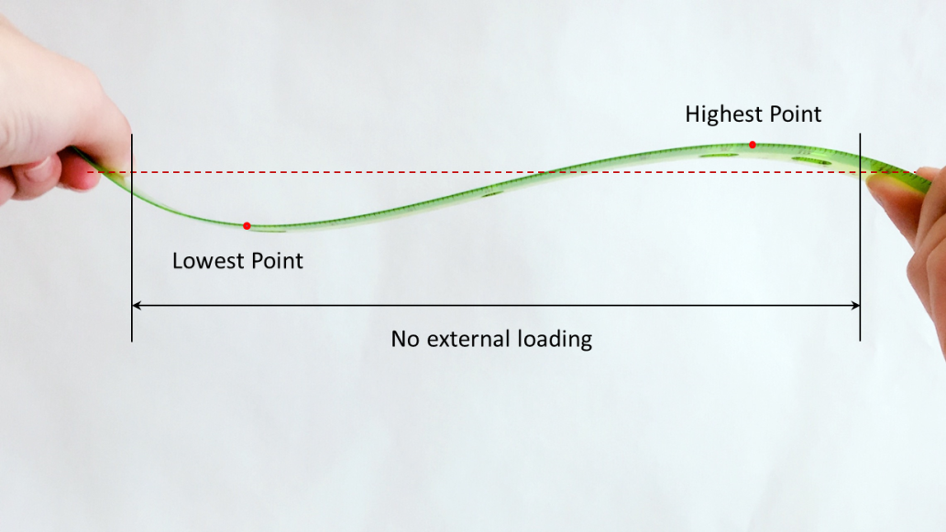

FIGURE 2.3 A non-loaded section of a ruler can exhibit a cubic shape

Once the deflection is described mathematically, secondary quantities such as slope, curvature, moment and shear are easy to derive. For example, the slope θ(x) along any particular section will be given by the expression

|  |  |  |
| --- | --- | --- |
|  | $θ\left(x\right)=\frac{dw}{dx} = b + 2cx + 3dx^{2}$. | (4) |

By default, an upward slope is considered positive.

The curvature Ƙ(x) of the beam along that segment will be related to the second derivative of the deflected shape, and if curvatures that produce sagging (make the beam have a local smiling shape as opposed to a frowning one), then

|  |  |  |
| --- | --- | --- |
|  | $Ƙ\left(x\right)=\frac{d^{2}w}{{dx}^{2}}=2c + 6dx$. | (5) |

The moment M(x) in a beam, taken as positive when it causes the beam to smile, is related to the curvature by

|  |  |  |
| --- | --- | --- |
|  | $$M(x) = EI Ƙ(x)$$ | (6) |

where I is the moment of inertia of the beam cross-section and E, the Young’s modulus of the material, describes its stiffness. Thus, we can write

|  |  |  |
| --- | --- | --- |
|  | $M\left(x\right)= EI Ƙ\left(x\right)= EI\frac{d^{2}w}{{dx}^{2}}= EI \left(2c + 6dx\right).$ | (7) |

A radio button pair in the Properties tab allows the user to choose whether curvature Ƙ(x) or moment M(x) is plotted.

The shear V(x) in a beam, taken by default to be positive when it acts downward on a right end or cut face of the beam, is related to its moment by the relationship

|  |  |  |
| --- | --- | --- |
|  | $V\left(x\right)=\frac{dM}{dx}$ | (8) |

and so we can write that

|  |  |  |
| --- | --- | --- |
|  | $V\left(x\right)= EI\frac{d^{3}w}{{dx}^{3}}= EI\left(6d\right)$. | (9) |

In general, beam loading is given by

|  |  |  |
| --- | --- | --- |
|  | $q(x)= EI\frac{d^{4}w}{{dx}^{4}}$, | (10) |

a re-arranged version of Equation (2). However, direct application of this relationship to the deflection cubic gives

|  |  |  |
| --- | --- | --- |
|  | $$q\left(x\right)= EI\frac{d^{4}w}{{dx}^{4}}=\frac{dV}{dx}=0$$ | (11) |

This result confirms that the transverse loading along each cubic segment must be zero, but it is not helpful for finding the values of the applied loads and reactions, both of which are considered to be applied within infinitesimal spaces between the polynomial segments (Fig. 2.1).

To calculate derivatives that are useful for finding these point loads, we examine the shear graph in Fig. 2.4, where we note a step change at location x*. The shear value a small distance Δ to its left at x*‑ Δ is

|  |  |  |
| --- | --- | --- |
|  | $V (x^{*}-Δ) =V_{L}$ | (12) |

while the shear value just to its right is

|  |  |  |
| --- | --- | --- |
|  | $$V (x^{*}+Δ) =V_{R}$$ | (13) |

Since it is true that

|  |  |  |
| --- | --- | --- |
|  | $$q\left(x\right)=\frac{dV}{dx}$$ | (14) |

we can integrate both sides of this equation from x*-Δ to x*+Δ to obtain

|  |  |  |
| --- | --- | --- |
|  | $\int{q\left(x\right)} =\int_{x^{*}-Δ}^{x^{*}+Δ}{\frac{dV}{dx}} =V_{R} - V_{L}$. | (15) |

The integral of the load over the small interval from x*-Δ to x*+Δ is clearly the value of the concentrated reaction or external load P applied at x*. Based on Equation (15), we can state that the point load P in the neighborhood of x* can be derived from the shear plot through the simple relationship

|  |  |  |
| --- | --- | --- |
|  | $P = V_{R} - V_{L}$. | (16) |

The concentrated loads associated with the applied loads and reactions are drawn as impulses in the spreadsheet load plot (See Fig. 2.4).

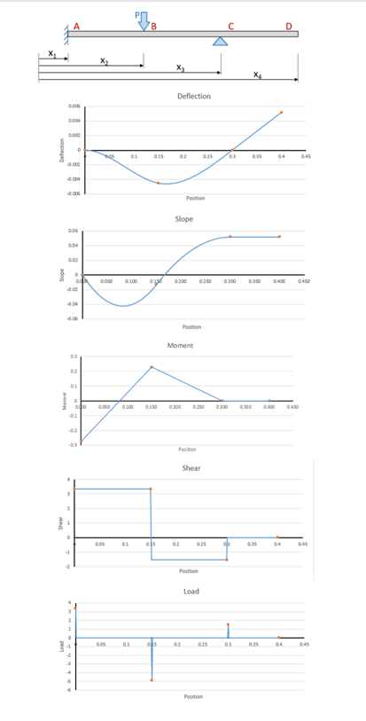

FIGURE 2.4 Spreadsheet calculations for a representative beam

# Input

The user inputs beam-specific information such as boundary conditions, applied loads and measured deflections using dropdown menus and boxes near the top of the Main tab of the spreadsheet. To begin this process, the drop-down menus associated with each of the four junction points A, B, C and D are used to specify the boundary condition, load or deflection measurement that occurs at each junction. The available options for each of the points are shown in Table 3.1.

TABLE 3.1 Available boundary condition, loading and deflection measurement options for the Points A, B, C and D

|  |  |  |  |
| --- | --- | --- | --- |
| A | B | C | D |
| Specified Load | Specified Load | Specified Load | Specified Load |
| Measured Deflection | Measured Deflection | Measured Deflection | Measured Deflection |
| Simply Supported | Simply Supported | Simply Supported | Simply Supported |
| Free | No Load | No Load | Free |
| Clamped |  |  | Clamped |

Depending on the option chosen for any given junction, the 6 cells below its drop-down menu will be adjusted by the spreadsheet to allow any additional required information to be entered.

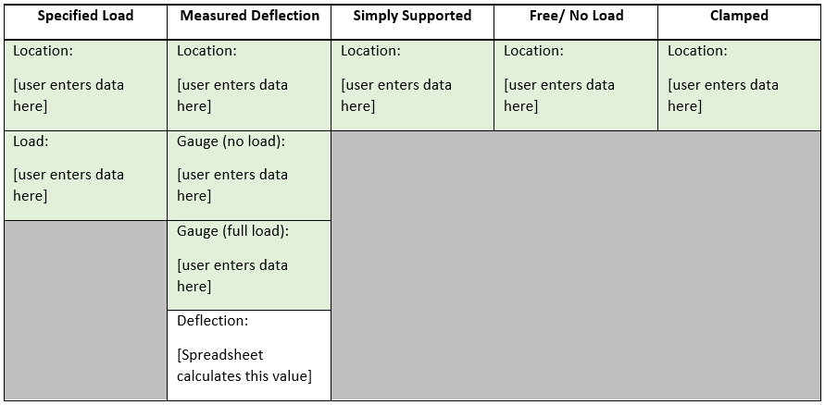

FIGURE 3.1 Additional user-entered information for each boundary condition, load or deflection measurement option

A Language tab along the bottom of the spreadsheet allows the titles on the spreadsheet to be customized by the user (Fig. 3.2), and a Properties tab allows the cross-sectional dimensions and material properties of beams in any conceptual models or matching experiments to be listed (Fig. 3.3).



FIGURE 3.2 A sample of the information on the language tab page

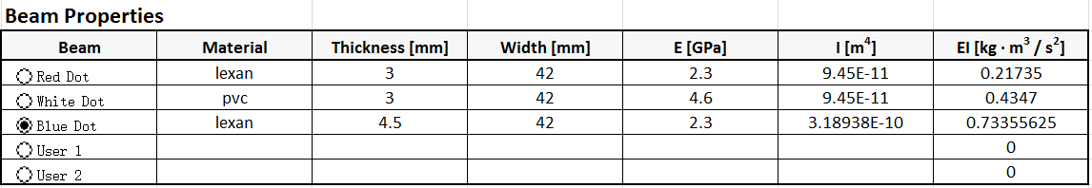

FIGURE 3.3 Representative beam properties in the Background Information tab

Key intermediate calculations are displayed in the Solver tab (Fig. 3.4), and they are useful for those who wish to understand the inner workings of the spreadsheet.

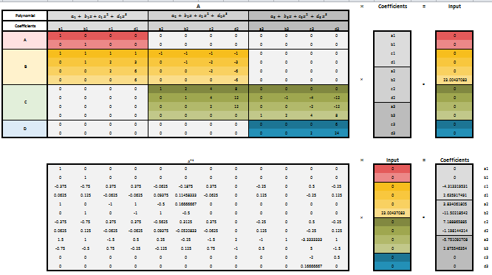

FIGURE 3.4 The structure of the cells in the Solver tab

# Construction of the Boundary Condition Equations

## Clamped Ends

If point A is clamped, then the deflection and slope are zero there. The value of x at Point A is x1, and Polynomial 1 describes the segment of the beam that includes point A. Thus we write

|  |  |  |
| --- | --- | --- |
|  | $$w_{1}\left(x_{1}\right)=0$$ | (17) |

and

|  |  |  |
| --- | --- | --- |
|  | $$θ_{1}\left(x_{1}\right)=0$$ | (18) |

as shown in the corresponding cell of Table 4.1. See also, the deflection and slope curves in Fig. 2.4. Using the explicit deflection equation (3), we get

|  |  |  |
| --- | --- | --- |
|  | $$w_{1}(x_{1}) = a_{1} + {b }_{1}x_{1} + c_{1}x_{1}^{2} + d_{1}x_{1}^{3} = 0$$ | (19) |

and this restraint provides one equation, namely that

|  |  |  |
| --- | --- | --- |
|  | $$a_{1} + {b }_{1}x_{1} + c_{1}x_{1}^{2} + d_{1}x_{1}^{3} = 0$$ | (20) |

In a similar way, the slope condition equation (4) requires that

|  |  |  |
| --- | --- | --- |
|  | $$θ_{1}(x_{1}) = b_{1} + 2c_{1}x_{1} + 3d_{1}x_{1}^{2} = 0$$ | (21) |

which implies that

|  |  |  |
| --- | --- | --- |
|  | $$b_{1} + 2c_{1}x_{1} + 3d_{1}x_{1}^{2} = 0$$ | (22) |

If, for illustrative purposes, x1=2 at the left end of the beam, these equations become

|  |  |  |
| --- | --- | --- |
|  | $$1a_{1} + 2b_{1} + 4c_{1}+ 8d_{1}= 0$$ | (23) |

and

|  |  |  |
| --- | --- | --- |
|  | $$1b_{1} + 4c_{1}+ 12d_{1}= 0$$ | (24) |

giving exactly the numbers in the first two rows of the two resulting conditions in the Solver tab of the spreadsheet.

If the clamped boundary were at D instead, we would have (Table 4.1) that

|  |  |  |
| --- | --- | --- |
|  | $$w_{3}(x_{4})= a_{3}+ b_{3}x_{4}+ c_{3}x_{4}^{2}+d_{3}x_{4}^{3}=0$$ | (25) |

and

|  |  |  |
| --- | --- | --- |
|  | $θ_{3}(x_{4})= b_{3}+2c_{3}x_{4}+3d_{3}x_{4}^{2}=0$. | (26) |

which would give rise to the constraint equations

|  |  |  |
| --- | --- | --- |
|  | $$a_{3}+ b_{3}x_{4}+ c_{3}x_{4}^{2}+d_{3}x_{4}^{3}=0$$ | (27) |

and

|  |  |  |
| --- | --- | --- |
|  | $$b_{3}+2c_{3}x_{4}+3d_{3}x_{4}^{2}=0$$ | (28) |

The last two rows in the matrix shown in the Solver tab of the spreadsheet (Fig. 3.4) correspond to these equations for the case where x = x4.

If the spreadsheet is used with the corresponding experimental apparatus, the clamed supports must turned so that the U-shaped cut-out faces away from the center of the beam, as illustrated in Fig. 4.1. Otherwise the innermost edge of the finite-width clamping zone will not correspond to the tick mark on the ruler. Clamped conditions are not allowed internal to the beam.

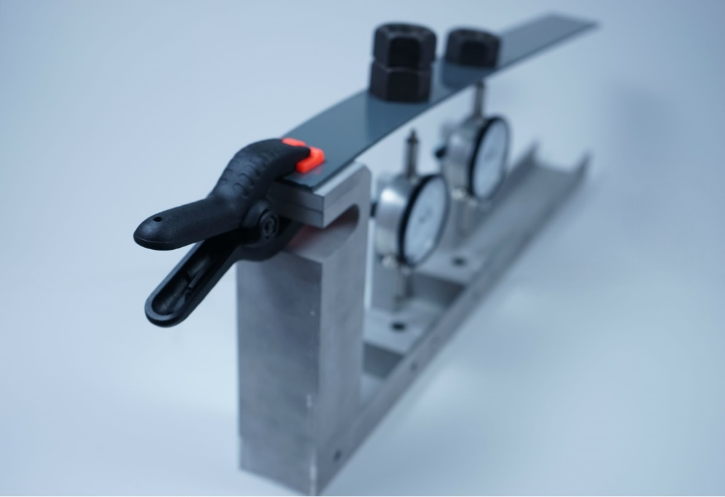

FIGURE 4.1 A Clamped Boundary Condition

TABLE 4.1 Equations arising from boundary conditions and applied loads

|  |  |  |  |  |
| --- | --- | --- | --- | --- |
| Boundary Condition | Location A  (x = x1) | Location B  (x = x2) | Location C  (x = x3) | Location D  (x = x4) |
| Specified Load | $V_{1}\left(x_{1}\right)=-P$ $Ƙ_{1}{(x}_{1})=0$ | $$w_{1}\left(x_{2}\right) {= w}_{2}\left(x_{2}\right)$$ $$θ_{1}\left(x_{2}\right)= θ_{2}(x_{2})$$ $$Ƙ_{1} \left(x_{2}\right)= Ƙ_{2}\left(x_{2}\right)$$ $$V_{1}\left(x_{2}\right)= V_{2}\left(x_{2}\right)+P$$ | $$w_{2}\left(x_{3}\right) {= w}_{3}\left(x_{3}\right)$$ $$θ_{2}\left(x_{2}\right)= θ_{3}\left(x_{3}\right)$$ $$Ƙ_{2}\left(x_{3}\right)= Ƙ_{3}\left(x_{3}\right)$$ $$V_{2}\left(x_{3}\right)= V_{3}\left(x_{3}\right)+P$$ | $$V_{3}\left(x_{4}\right)=+P$$ $$Ƙ_{3}\left(x_{4}\right)=0$$ |
| Measured Deflection | $$w_{1}\left(x_{1}\right)=d$$ $$Ƙ_{1}\left(x_{1}\right)=0$$ | $$w_{1}\left(x_{2}\right)=d$$ $$w_{2}\left(x_{2}\right)=d$$ $$θ_{1}\left(x_{2}\right)= θ_{2}(x_{2})$$ $$Ƙ_{1} \left(x_{2}\right)= Ƙ_{2}\left(x_{2}\right)$$ | $$w_{2}\left(x_{3}\right)=d$$ $$w_{3}\left(x_{3}\right)=d$$ $$θ_{2}\left(x_{3}\right)= θ_{3}(x_{3})$$ $$Ƙ_{2} \left(x_{3}\right)= Ƙ_{3}\left(x_{3}\right)$$ | $$w_{3}\left(x_{4}\right)=d$$ $$Ƙ_{3}\left(x_{4}\right)=0$$ |
| Simple support | $$w_{1}\left(x_{1}\right)=0$$ $$Ƙ_{1}\left(x_{1}\right)=0$$ | $$w_{1}\left(x_{2}\right)=0$$ $$w_{2}\left(x_{2}\right)=0$$ $$θ_{1}\left(x_{2}\right)= θ_{2}(x_{2})$$ $$Ƙ_{1} \left(x_{2}\right)= Ƙ_{2}(x_{2})$$ | $$w_{2}\left(x_{3}\right)=0$$ $$w_{3}\left(x_{3}\right)=0$$ $$θ_{2}\left(x_{3}\right)= θ_{3}(x_{3})$$ $$Ƙ_{2}\left(x_{3}\right)= Ƙ_{3}(x_{3})$$ | $$w_{3}\left(x_{4}\right)=0$$ $$Ƙ_{3}\left(x_{4}\right)=0$$ |
| Free | $$Ƙ_{1}\left(x_{1}\right)=0$$ $$V_{1}\left(x_{1}\right)=0$$ | n/a | n/a | $$Ƙ_{3}\left(x_{4}\right)=0$$ $$V_{3}\left(x_{4}\right)=0$$ |
| No Load | n/a | $$w_{1}\left(x_{2}\right) {= w}_{2}\left(x_{2}\right)$$ $$θ_{1}\left(x_{2}\right)= θ_{2}(x_{2})$$ $$Ƙ_{1} \left(x_{2}\right)= Ƙ_{2}\left(x_{2}\right)$$ $$V_{1}\left(x_{2}\right)= V_{2}\left(x_{2}\right)$$ | $$w_{2}\left(x_{3}\right) {= w}_{3}\left(x_{3}\right)$$ $$θ_{2}\left(x_{2}\right)= θ_{3}(x_{3})$$ $$Ƙ_{2} \left(x_{3}\right)= Ƙ_{3}\left(x_{3}\right)$$ $$V_{2}\left(x_{3}\right)= V_{3}\left(x_{3}\right)$$ | n/a |
| Clamped | $$w_{1}\left(x_{1}\right)=0$$ $$θ_{1}\left(x_{1}\right)=0$$ | n/a | n/a | $$w_{3}\left(x_{4}\right)=0$$ $$θ_{3}\left(x_{4}\right)=0$$ |

## Simple Supports

Simple supports provide vertical reactions, but carry no moment. If this kind of support occurs at the left end (at A), we have

|  |  |  |
| --- | --- | --- |
|  | $$w_{1}(x_{1}) = a_{1} + {b }_{1}x_{1} + c_{1}x_{1}^{2} + d_{1}x_{1}^{3} = 0$$ | (29) |

and

|  |  |  |
| --- | --- | --- |
|  | $Ƙ\left(x_{1}\right)= 2c_{1}+6d_{1}x_{1}=0$. | (30) |

A simple support at the right end gives similar equations, as shown in Fig. 4.1.

If a simple support occurs internally (at B, for example), then the zero deflection it enforces applies to both of the deflection polynomials (w1 and w2) that impinge on Point B, and we have that

|  |  |  |
| --- | --- | --- |
|  | $$w_{1}(x_{2})= 0$$ | (31) |
|  | $$w_{2}(x_{2})= 0$$ | (32) |

It is further required that the beam must not have a sharp bend at B, and so the slope of the polynomial describing the portion of it just to the left of B must match the slope of the polynomial describing the portion just to its right (Fig. 4.2). In other words, we must have that

|  |  |  |
| --- | --- | --- |
|  | $$θ_{1}\left(x_{2}\right)=θ_{2}\left(x_{2}\right)$$ | (33) |

Because a simple support introduces no moment where it acts, the moment in the beam just to the left of B must be equal to that just to its right (Fig. 2.4). Thus, we must have that

|  |  |  |
| --- | --- | --- |
|  | $$M_{1} \left(x_{2}\right)= M_{2}(x_{2})$$ | (34) |

or, equivalently, that

|  |  |  |
| --- | --- | --- |
|  | $$Ƙ_{1} \left(x_{2}\right)= Ƙ_{2}(x_{2})$$ | (35) |

The same constraint equations result regardless of whether they are derived from the moment or curvature equations. As shown here and in Table 4.1, this boundary condition gives rise to four constraint equations if it occurs internal to the beam,

It turns out that every allowed choice of a boundary condition, load or deflection measurement (Table 4.1) gives rise to two constraint equations when it occurs at the end of a beam (Points A or D) and four when it occurs internally (at B or C).

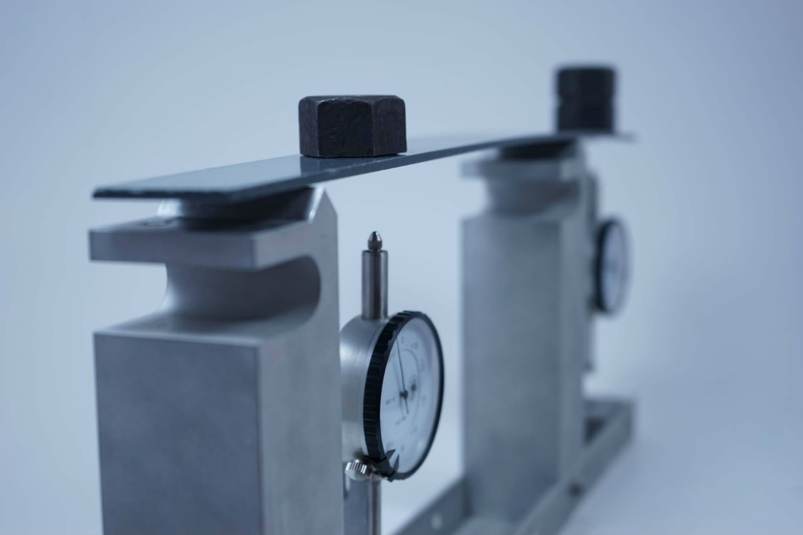

FIGURE 4.2 Two Simply Supports

## Free Ends

If an end of a beam is free, that is if it is unattached to a support and carries no applied loads or moments, one can show that the curvature (or moment) and shear at that end are zero (Table 4.1 and Fig. 2.4). For example, the boundary condition equations associated with a free end at A are

|  |  |  |
| --- | --- | --- |
|  | $$M(x_{1}) = EI (2c_{1} + 6d_{1}x_{1}) = 0$$ | (36) |

and

|  |  |  |
| --- | --- | --- |
|  | $V_{1}(x_{1}) = EI (6d_{1}) = 0$, | (37) |

which give rise to the constraint equations,

|  |  |  |
| --- | --- | --- |
|  | $$EI (2c_{1}+ 6d_{1}x_{1}) = 0$$ | (38) |

and

|  |  |  |
| --- | --- | --- |
|  | $EI (6d_{1}) = 0$. | (39) |

Similar equations result for a free end at D.

## No Load

The spreadsheet requires that 4 Points be identified by the user so that the solution matrices are properly populated. Sometimes fewer than 4 Points are meaningful, as in an end-loaded cantilever beam (Fig. 4.3). “No load” points are then added arbitrarily so that a total of 4 points can be defined (Fig. 4.4). The positioning of these “dummy points” does not affect any of the plots, but for the sake of matrix conditioning and solution accuracy, they should not be placed unnecessarily close to any of other points.

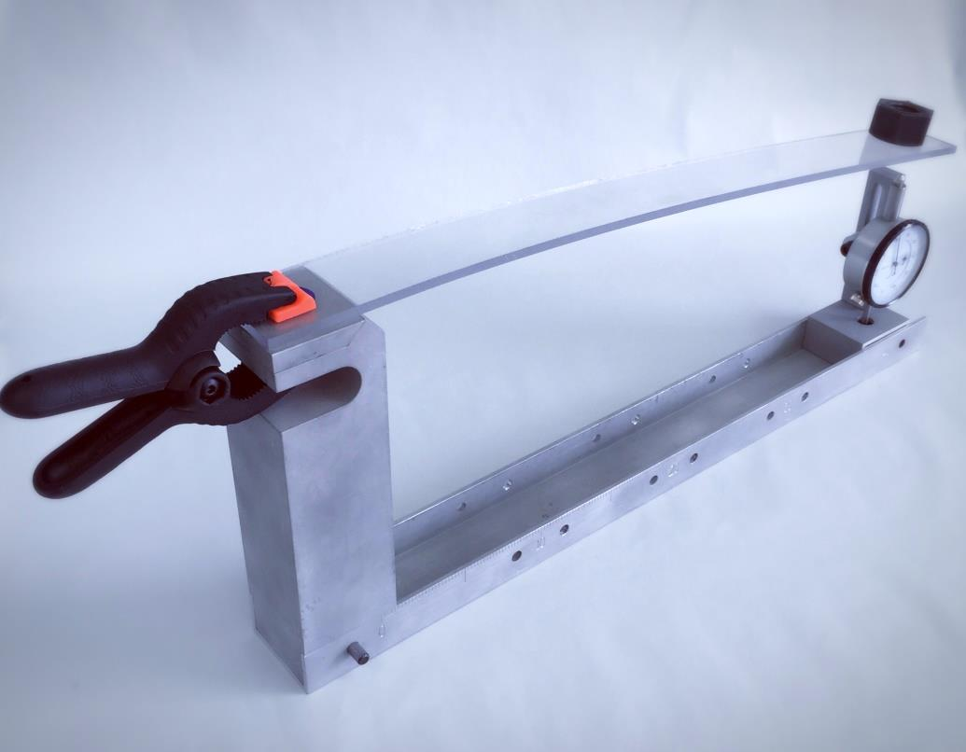

FIGURE 4.3 A Cantilever Beam with an End Load

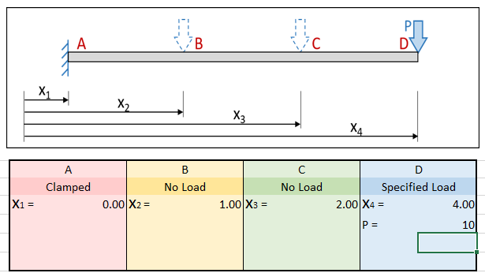

FIGURE 4.4 A cantilever beam with “No load” or “dummy” points.

At an arbitrary point (say Point B) inside a beam, away from any concentrated loads that might arise from externally-applied loads or reactions, all of the beam functions should be smooth and continuous (Fig. 2.4). These continuity equations can be written as

|  |  |  |
| --- | --- | --- |
|  | $$w_{1}\left(x_{2}\right) {= w}_{2}\left(x_{2}\right)$$ | (40) |
|  | $$θ_{1}\left(x_{2}\right)= θ_{2}(x_{2})$$ | (41) |
|  | $$Ƙ_{1} \left(x_{2}\right)= Ƙ_{2}\left(x_{2}\right)$$ | (42) |

And

|  |  |  |
| --- | --- | --- |
|  | $$V_{1}\left(x_{2}\right)= V_{2}\left(x_{2}\right)$$ | (43) |

and they provide 4 equations at any internal points where they occur.

## Specified Loads

If a point load is applied at the left end of a beam (at A), then the moment at that end is zero

|  |  |  |
| --- | --- | --- |
|  | $M_{1}{(x}_{1})=$ 0 | (44) |

and the shear is equal to

|  |  |  |
| --- | --- | --- |
|  | $$V_{1}\left(x_{1}\right)=-P$$ | (45) |

(Table 4.1 and Fig. 4.5) The negative sign is needed since load is considered positive upwards while shear is deemed positive when it is down on a right cut face (up on a left cut face as at A). On a right end, as at Point D, shear is positive downwards while load is positive upwards and so no negative sign is required. Note the shear diagram in Fig. 2.4.

When point loads occur internally (as at point B), continuity of the beam there requires that

|  |  |  |
| --- | --- | --- |
|  | $$w_{1}\left(x_{2}\right) {= w}_{2}\left(x_{2}\right)$$ | (46) |
|  | $$θ_{1}\left(x_{2}\right)= θ_{2}(x_{2})$$ | (47) |

Note that a jump of magnitude P occurs in the shear diagram.

|  |  |  |  |
| --- | --- | --- | --- |
|  | $$Ƙ_{1}\left(x_{2}\right)= Ƙ_{2}(x_{2})$$ | (48) | |
|  | $$V_{1}\left(x_{2}\right)= V_{2}\left(x_{2}\right)+P$$ | | (49) |
|  |  |  | |

The No load case is actually a special case of this one, with P set to zero.



FIGURE 4.5 An applied load

## Measured Deflections

If the deflection d is known at a particular location, that information can be used to help determine some of the polynomial coefficients. For example, if the deflection at the left end (at A) is known, then one can write that

|  |  |  |
| --- | --- | --- |
|  | $$w_{1}\left(x_{1}\right)=d$$ | (50) |

and that

|  |  |  |
| --- | --- | --- |
|  | $$M_{1}\left(x_{1}\right)=0$$ | (51) |

In principal, the observed deflection might have been forced, as in the cantilever beam shown in Fig. 4.1. In that case, it is clear that an external load or a reaction from an offset simple support could have been present there. Either of these situation would produce a jump in the shear curve. As a result, it would be incorrect to assume that no load is present at location with known (or forced) displacements, and it would be erroneous to assume zero shear there. Indeed, the measured or forced displacement condition can be used to analyze beams with offset simple supports (Fig. 4.2).

If an applied load acts internally (as at B), then both of the deflection polynomials that approach Point B must produce the observed deflection, and so we have that

|  |  |  |
| --- | --- | --- |
|  | $$w_{1}\left(x_{2}\right)=d$$ | (52) |
|  | $$w_{2}\left(x_{2}\right)=d$$ | (53) |

In addition, the beam slope and moment must be continuous at B, and so we have that

|  |  |  |
| --- | --- | --- |
|  | $$θ_{1}\left(x_{2}\right)= θ_{2}(x_{2})$$ | (54) |
|  | $$M_{1} \left(x_{2}\right)= M_{2}\left(x_{2}\right)$$ | (55) |

as shown in Table 4.1. As in the case of a beam end, the reported internal displacement may have been “forced” by an applied load or an offset simple support, and a jump may occur in the shear curve.

The spreadsheet calculates the magnitude of any jump that is produced in the shear curve by the specified deflection, and uses it to calculate the applied load curve (Fig. 2.4).

# Equation Solution

As shown in Table 4.1, a boundary condition, applied load or specified displacement condition gives rise to two constraint equations at each end of the beam. In addition, every internal junction point give rise to 4 equations. For a beam with 3 segments there are 2 external points (A and D) and 2 internal points (B and C), giving a total of 12 constraint equations. Each of the 3 segments of the beam are described by a cubic deflection function having 4 unknowns and so the total number of unknowns is also 12. If the number of cubic segments is changed and the number of internal points correspondingly changed, it turns out that there will always be just enough equations to find all of the unknown coefficients.

The coefficient constraint conditions are shown in the Solver tab of the spreadsheet (Fig. 3.4). There, it is clear how the 2+4+4+2 constraint equations produce equations for solving for the 12 polynomial equations. Fig. 5.1 shows the 12 equations used in the solver tab with correspond color.

Provided that none of the junction points, such as the No load dummy points is placed at essentially the same location as another point, the resulting equations are well conditioned. If, furthermore at least one non-zero load or deflection is specified, the equations cease to be homogeneous, and a unique solution can be found.

To solve the resulting matrix constraint equation,

|  |  |  |
| --- | --- | --- |
|  | $$A c=g$$ | (56) |

Where **c** is the matrix of unknown polynomial coefficients, the 12 by 12 matrix **A** is inverted (Fig. 3.4) and forward multiplied by **g**, the vector on the right hand side of the original equation. The result is

|  |  |  |
| --- | --- | --- |
|  | $$A^{-1} g=c$$ | (57) |

which gives the unknown coefficients **c**.



FIGURE 5.1 Equations options in spreadsheet

# Curve Plotting

Once the 12 coefficients for the three segmental cubic deflections equations are known, the slope, curvature, shear and load curves can be found easily, using the relationships outline in Section 2.

The resulting equations can be plotted by specifying an arbitrary number of calculation points along each segment of the beam and evaluating the various equations at each of these points. The only difficulty that arises is that jumps can occur in the shear curve and pulses in the load curves (Fig. 2.4), and this can be overcome by plotting many points along each polynomial sections, as we have done.

Some of the points from the Plotting Data tab used to calculate the curves shown in Fig. 2.4 are shown in Fig. 6.1.



FIGURE 6.1 Plotting tab in Spreadsheet

For further information, please visit our website: <http://www.civil.uwaterloo.ca/brodland>.