Gothic Cathedral Cross-section
Many cathedrals and other tall Gothic buildings used a combination of horizontal and vertical members, including flying buttresses. In this exercise you will explore why this is the case, using a representative Gothic cathedral cross-section and designs of your own making.

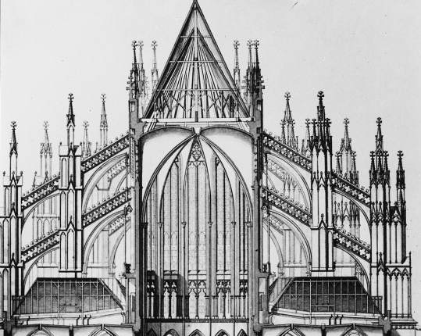
http://www.banupekol.com/blog/2011/08/20/the-parler-legacy/ (from www.artandarchitecture.org.uk)
Cross-section of Cologne Cathedral in Germany (once the world’s tallest building)

Objectives:
To understand the forces in a traditional gothic cathedral, the role of flying buttresses, and the importance of the order in which various components of a structure are assembled.
To collect the data, images or videos needed to produce the assigned deliverable (report, photo essay or video) associated with this activity.

Apparatus:
From a “Cathedral” kit and the classroom trolley, put together the following:
Label | Quantity | Item(s)
A | 6 | Vertical members with 2 notches (for piers)
B | 4 | Flyers
C | 4 | 3” blocks (for walls or columns)
D | 2 | 6” blocks (for walls or columns)
E | 2 | 9” blocks (for walls or columns or a ceiling)
F | 2 | Buttresses (large blocks with single notches)
G | 2 | Vaulted ceiling segments
H | 1 | Roof assembly
I | 1 | Rubber mat
J | 1 | Roll of tape

Flyer
Wall
Wall or column
Pier
Roof assembly
NAVE
AISLE
Buttress
Vaulted (curved) ceiling

Schematic of a Gothic Cathedral (Apparatus items E, I and J not shown)

Recommended Procedure:
- Try to assemble the various components of the cathedral to match the schematic drawing shown below, doing so in such an order that one piece can be added at a time and no part of the structure falls down. Note, however, that the two parts of the ceiling arch must be added simultaneously. Please be careful with the blocks – and especially the roof structure, which should always be added last – cushioning anything that might fall.
Schematic of a Possible Cathedral Design

- Describe one construction sequence that works and one that does not, and explain why each gives rise to its particular outcome.
- Suppose that the proximity of adjacent buildings or other features prevented the use of a double flying buttress as in the design above. What other options might work? Make a sketch of 3 or 4 ideas, but at this point do not try them out. Changing the shape or size of the interior of the cathedral is allowed. If you propose using tape in some way, explain what it does in terms of load carrying or changing the connections between certain structural members. Your design need not be symmetric.
- Now try out your designs and report which work and which do not. Try to explain what you observe.
- Can you make any of the collapsing designs stand by adding extra vertical weight to one or more of the piers? (Designers actually did this in some cathedrals.)
- What kinds of loads does the pier have to carry? Describe these loads (forces) using the descriptors introduced in Chapter 2 of the course notes.
- If you have time, propose and test other possible building designs of your own making.
- If you have time, try to figure out the design that you can build with the given materials that gives the highest interior space and has a curved ceiling. Remember, please be careful with the blocks.
- If you use a straight block for the ceiling, how does that affect the design? Try building something based on that design, but do not make your model higher than 2 feet tall. Do you know why Gothic designs did not use flat ceilings?
- Summarize 4 to 5 points that you learned about the design and construction of a cathedral or other classic Gothic building.

Modern design formulas and computational analyses did not exist when Gothic cathedrals and other ancient buildings were conceived, and proposed designs and construction strategies were routinely tested in advance of actual construction using sophisticated and detailed scale models.

Wrapping up:
- Organize and place the apparatus back in the container(s) in which it came.
- Return the apparatus to the designated location.
- Prepare and submit the specified deliverable for this activity by the stated deadline. Include sketches of your designs, and highlight the main things that you learned.

