Multi-force Body

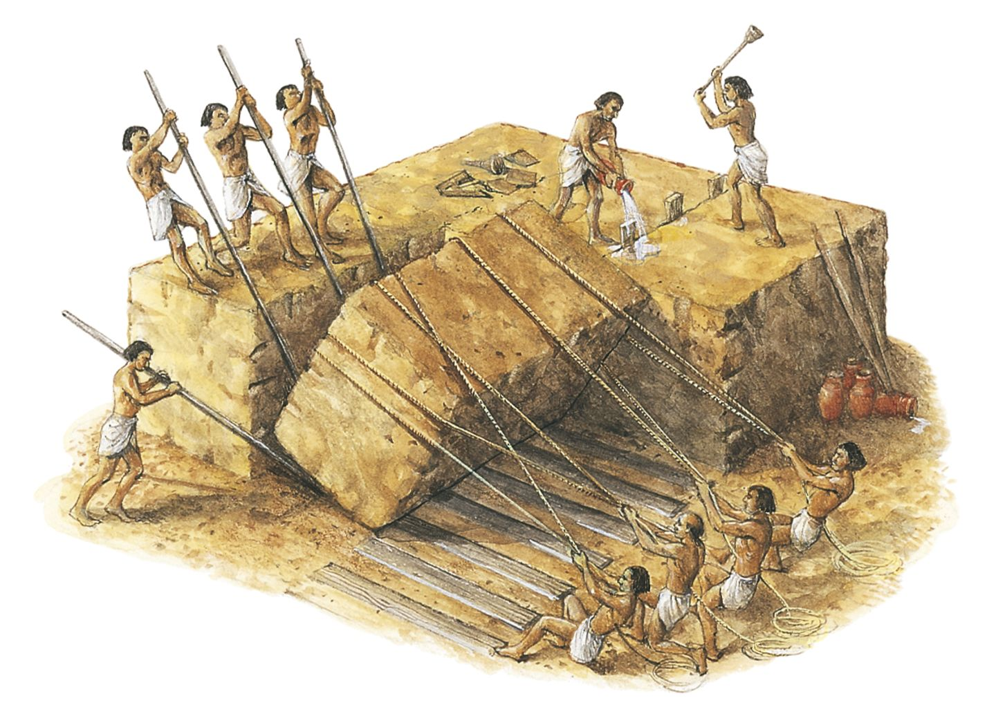
http://www.dkfindout.com/uk/history/ancient-egypt/building-pyramids/

Objectives:
To discover the relationships that forces acting on a body must have in order for that body to be in equilibrium.
To collect the data, images or videos needed to produce the required deliverable (activity report, photo essay or video).

Apparatus:
From an “Equilibrium” kit and the classroom trolley, put together the following:
Quantity | Item(s)
1 | Plywood “rigid” body with attachment points
4 | Spring scales
1 | Ruler
3 | Large (24” x 35½”) sheets of paper
Spring scale

Rigid body
Button

Note that the scales used in this project were originally designed for weighing fish and so are calibrated in units of kg and lb. The scales actually report kgf and lbf, the gravitational force that would act on fish or other weighed objects having corresponding masses in kg and lbm. Since we are using the scales to measure forces, it would have been more convenient for us if they had been calibrated in units of N.
Note, also, that the scales have a maximum-load indicator that can be reset to zero, and that it can be quite useful for measuring applied loads.
Load and max indicator stay together as load increases
Load and max indicator separate when load increases
Load indicator
Maximum load indicator
DO NOT ALLOW THE FORCE IN ANY OF THE SPRING SCALES TO EXCEED 5kg.

Recommended Procedure:
- How can you convert measurements in kg (actually kgf) to N? Convert a spring scale reading of 5kg to N.
- In the photograph on the first page of this activity, identify a rigid body and describe the forces on it.
- Attach a spring scale to one of the brass buttons (sleeves) on the body at a location of your choice. Can you apply a tension of 3 kgf to the body using a spring scale, and while applying no other forces to the body, have it remain stationary? Why or why not? The hypothesis being tested in this part of the activity is “that a ‘body’ can be in equilibrium under the action of a single, non-zero force.” Does the hypothesis turn out to be true or false? Can you relate what you observe to one of Newton’s Laws?

- Place the apparatus on top of one of the pieces of paper, attach a second bar and spring scale and slowly increase the load in the first scale (master) until it reaches a tension of 2 kgf. Apply whatever load is necessary to the second spring scale (slave) so that it eventually stops the body from moving. The body and scales should be allowed to rotate in the plane of the paper should they display a tendency to do so. Note the magnitudes of the applied forces (the maximum load indicators may be useful for obtaining these values). Before releasing the loads, trace the outline of the rigid body (as shown in the figures below and on the next page), make dots or small circles in the center of each of the buttons by inserting your pen through each one, and draw along each of the spring scale rods. Record the forces applied by each spring scale. Place the letter corresponding to this activity part on the sheet of paper and draw a box around it. What do you notice about the magnitude of the force in the second spring?
2.0 kgf
1.9 kgf

- Use the ruler to draw straight lines along the directions of the loads applied by the spring scales, making their lengths proportional to the magnitude of the applied loads. Put arrowheads in the direction in which the scales pulled (see figure below). You may recognize these arrows as representing vectors. Do you notice anything interesting about the geometric relationship between the directions and alignment of the spring scale rods (and the attachment points)? You might want to extend the tail ends of the arrows using a dashed line (as shown in the figure) so as to highlight these relationships. Note that there is error in each of your measurements and so you might speculate about relationships that appear to possibly be true. Further experiments could be used to support or disprove your conjectures.
2.0 kgf
1.9 kgf

- Repeat part (D) of the experiment with a tension of 4 N in the master spring scale. What is the force in the slave scale? Can you draw any tentative conclusions? Can you relate this finding to one of Newton’s Laws? You might use the back of the first sheet of paper for this part of the activity.
- Now choose a different pair of attachment points and repeat parts D and E of the experiment. What do you notice? Do your tentative conclusions still hold?

- Now repeat D and E, but with 3 attached scales. Increase the force in one of the scales (the master scale) to approximately 2 N and use whatever forces are necessary in the other two to bring the body into equilibrium. Be careful not to exceed a load of 5knf in any of the scales. As before, trace the plywood body, the spring scale rods and the inside of the tubes at the attachment points, and record the forces on the drawing.
2.0 kgf
2.4 kgf
1.6 kgf

- Now add arrows along the load directions as in (F) and extend the backs of the arrows using dashed lines. Speculate about possible relationships between the dashed lines.
2.0 kgf
2.4 kgf
1.6 kgf

- Copy the arrows you have drawn to an empty space on the piece of paper, placing them so that they lie head to tail, as shown below. Be careful to maintain their lengths and directions. What do you notice?
or

- If you have studied vectors, to what mathematical operation does putting vectors head to tail correspond? What does your finding in part (J) mean in terms of the force vectors acting on the body? If you have not studied vectors, just report that you have not as your answer for this part of the activity.

- Now repeat parts H, I and J of this activity using the same attachment points that you just used, but a trio of applied loads that have different directions and magnitudes than those you just used. Do your earlier observations about the line intersections in part (I) and the head to tail vectors in (J) still hold?
- Finally, repeat parts H, I and J for a system with 4 forces (spring scales). Do your conclusions from part (I) still hold? What about your conclusions from part (J)? Provide evidence for your answers.
- Imagine that you observed the stone block in the photo shown at the start of this activity from its (left) end. If you represented each of the applied forces with an arrow (vector) what relationships might you expect to see between these arrows?
- Put together a paragraph, photo or short piece of video footage, as appropriate, to summarize the main things that you learned.
- If you have extra time, you might want to do some of the steps in Activity A1.1 – Forces at a Point.

Wrapping up:
- Organize and place the apparatus back in the container(s) in which it came.
- Return the apparatus to its designated location.
- Prepare and submit the specified deliverable for this activity by the stated deadline. Include your tracings with your submission.

