Dams & Retaining Walls
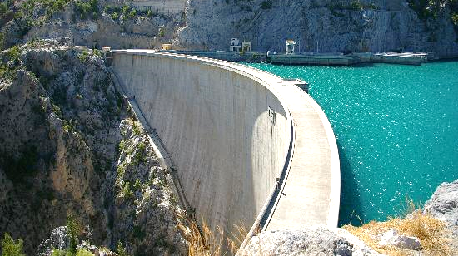
http://prophetsandpopstars.com/dam-breaking/
http://www.landscapehdwalls.com/rice-terraces-1167/

Objectives:
To discover, from a structural point of view, how dams and a retaining walls work.
To collect the data, images or videos needed to produce the required deliverable (activity report, photo essay or video).

Apparatus:
From a “Soil and Water” kit and the classroom trolley, put together the following:
Quantity | Item(s)
1 | Plexiglas box
1 | Marbles in a storage container
3 | Scale-model retaining walls
1 | Small rubber pad
2 | File folders
1 | Pair of scissors
1 | Ruler

Dam – Recommended Procedure:
Please ensure that the marbles you work with do not “escape.” Any marbles that “make a run for it” should be captured promptly.
- Empty all items out of the Plexiglas box.
- Cut a piece of file-folder cardboard so that it can be used to form a flat dam across the Plexiglas box. It should just slide into the two vertical grooves on the inside of the box. Carefully fill the larger side of the box with marbles (in this part of the activity, they represent water). How high can you make the pool of marbles before the dam fails? Use a ruler to measure this depth (the depth of the marbles, not including the thickness of the bottom of the box).
- Make a new dam, but make this one approximately ½” wider than the width of the box. When you install it, it will be curved. Try it curved toward the pool of marbles and away from it. Report the marble fill depths at which each fails.
- Repeat the experiment for the dam design that carries the highest load, using your hands to adjust the dam shape or otherwise “help” the dam during filling. Now, how deep can you make the marble pool? Does it matter whether you pour the marbles in or set them in carefully or if you drop one or two on an otherwise static pool? Can you postulate why these factors make a difference?
- Based on your experiments, draw one or more conclusions about possible design strategies for dams. Can you relate any of these conclusion to the shapes you see in the photographs at the beginning of this section?
- Return the marbles to their storage container.

Retaining Wall – Recommended Procedure:
- If you were going to use the L-shaped wooden retaining wall to hold back a bunch of marbles, which way would you orient it? I.e., would you place the base of the leg toward the marbles (surrogate soil) or away from them? Why?
or
“Leg out” design
“Leg in” design

- Now, try out both designs. Always place the rubber pad under the retaining walls (unless instructed otherwise) before beginning to backfill with marbles. Was your original thinking about which design would be better correct” Why or why not?
- What do you conclude about how a retaining wall functions?
- Repeat part (B) of the activity using the metal retaining wall.
- Before you repeat part (B) using the wooden wall with the short leg, guess whether it will stand or tip over. If you find that it tips at a particular fill height, record that height. If you do not have enough marbles to create a fill height that tips it, move the wall closer to one end of the box so that fewer marbles are needed to create a given depth.
- Remove the rubber mat and repeat parts B and D of the activity. What do you discover?
- Describe two ways in which retaining walls can fail. See if you can find examples of each online.
- Try to explain at least two of the principles by which a retaining wall works. (You will learn much more about retaining walls in some of the geotechnical courses.)
- Could a retaining wall of the type demonstrated here be used as a dam? Why or why not? Think carefully about your answer.
Remember the point is not to get the expected or “right” answer, but to begin thinking about how things work. That is not to say that we do not expect you to get very good and exactly correct answers by fourth year, but as we start the learning process, learning to think critically is more important than getting the same answers as everybody else. It is fine if different group members come to different conclusions, and in that case, both conclusions should be reported, along with the arguments by which they were obtained.

- Bonus question: Find at least one other strategy for retaining wall design. Explain how the model could be modified so that that strategy could be demonstrated.
- Put together a paragraph, point-form summary or video clip, as appropriate, summarizing the main things that you learned.

Wrapping up:
- Organize and place the apparatus back in the container(s) in which it came.
- Return the apparatus to the designated location.
- Prepare and submit the specified deliverable for this activity by the stated deadline.

