**Construction Details for the “Shear in Beams” Model**

(Downloadable from http://www.civil.uwaterloo.ca/brodland/)

The core of the “Shear in Beams” model consists of 14 wooden blocks (Figure 1). We used maple for its light colour, attractive grain, mechanical stability and durability. Each block is 3.12 x 3.12 x 20 cm in size, and it is coated with a transparent acrylic finish to preserve its appearance.

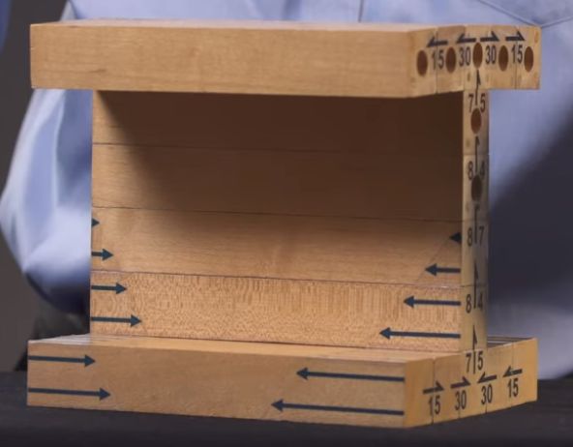

*Figure 1 – The Wooden Parts of the Model*

The compressive bending stresses that act on the beam (see the Worked Example at the above referenced website) are represented by blue arrows (Figure 1) overlaid on the blocks below the neutral axis. The artwork for these self-adhesive labels is also available for download on the website.

To represent the tensile bending stresses that act on the beam, Plexiglas blocks of trapezoidal and triangular shape are attached to the ends of the wooden blocks on the “tension” side of the beam (that is above the neutral axis). Note that the 7 blocks on the one end of the beam are of different lengths than those on the other (Figure 2).

**5**

**7.5**

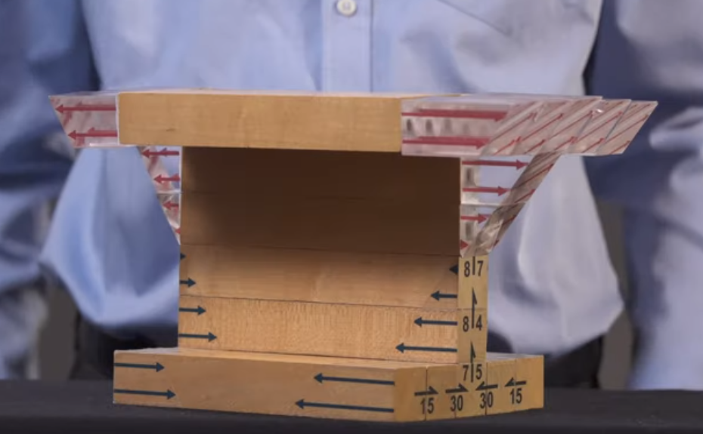

*Figure 2 – The model with its Plexiglas Blocks Attached*

The blocks on the one end have a maximum length of 5cm and those on the other 7.5. In retrospect, the model and worked example would have matched slightly better if the ratio of the bending stresses on the two ends of the worked example were 2:3 rather than 1:2.

The wooden blocks attach to each other through wooden dowels (Figure 3). All of our dowels had the same spacing, and as a result the model could be assembled incorrectly. We suggest that the dowel spacing for the blocks on the top left be different than the top right (Figure 4), and different on the bottom left than on the bottom right. The dowels for the Plexiglas blocks that represent the larger bending stresses might also be made a different diameter than those used to anchor the blocks representing the smaller bending stress. Errors in assembly can be difficult to identify, and correct assembly can only be assured by checking the directions of the shear arrows (Figure 4). A better approach would be to incorporate simple physical features that prevent incorrect assembly.

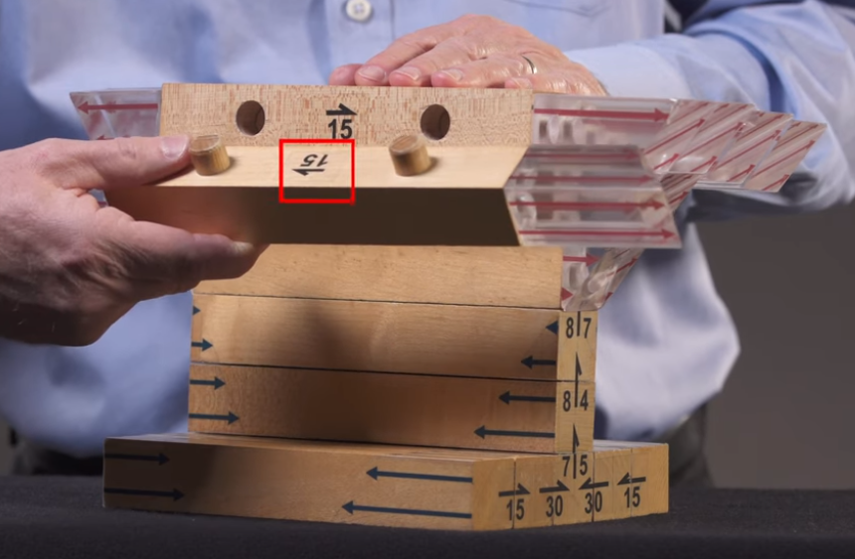

*Figure 3 – Wooden Dowels Hold the Blocks Together*

The last step in construction of the model is addition of the black shear arrows (Figures 1-4). We found self-adhesive labels to work well for this purpose, and the artwork we used can be downloaded from our website. Care and thought is required to get the placement and directions of the arrows just right. You might want to view our video (<https://www.youtube.com/watch?v=aivDhiLwu8E>) one or more times before attaching the shear arrows.

*Figure 4 – Dowels and Shear Arrows*