Arches
The elegance and efficiency of arches have made them a popular structural and architectural element for millennia. In this exercise you will explore how they work.
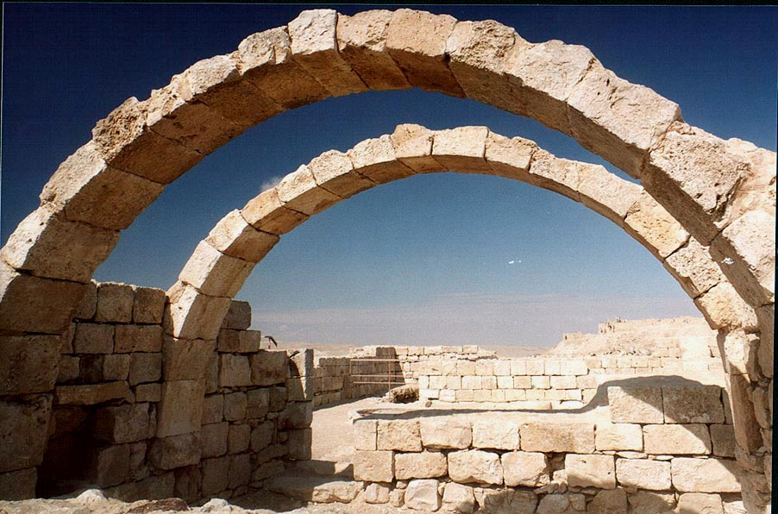
http://www.asergeev.com/pictures/archives/2001/177/jpeg/15.jpg 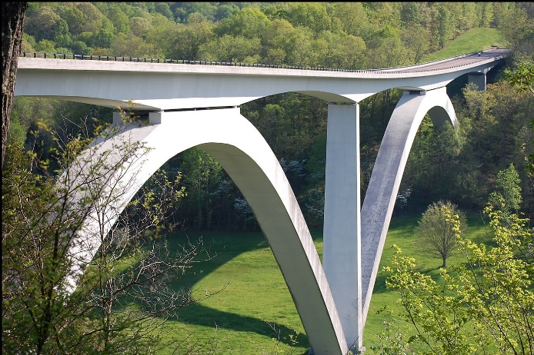
http://claudiaperezr.pbworks.com/w/page/70994682/BRIDGE

Objectives:
To learn how arches and cables (chains) carry load.
To collect the data, images or videos needed to produce the assigned deliverable (report, photo essay or video) associated with this activity.

Apparatus:
From an “Arches” kit and the classroom trolley, put together the following:
Quantity | Item(s)
1 | Rubber mat
5 | 1½ x 3 x 8½” wooden blocks with end angles of 18°  (No designation markings)
5 | 1½ x 1½ x 8” wooden blocks with end angles of 18°  (White dot)
2 | 1½ x 1½ x 8¾” wooden blocks with end angles of 30° & 6° (Red dot near 30° end )
2 | 1½ x 1½ x 5½” wooden blocks with end angles of 8°  (Yellow dot)
2 | 1½ x 1½ x 5¼” wooden blocks with end angles of 45° & 11° (Green dot near 45° end )
3 | 1½ x 1½ x 3¼” wooden blocks with end angles of 30°  (Blue dot)
1 | 48”-long piece of chain
2 | Large (24” x 35½”) sheets of paper

Recommended Procedure:
- Spread out the rubber mat on your table top and do all work on top of it.
- Try to avoid damage to the blocks by cushioning any blocks that fall.
- Build a semi-circular arch with the 5 - 1½ x 3 x 8½” blocks (no dot). Experiment with the radial positions of the blocks in the arch and see what you can learn about how an arch works. Report your findings using words and sketches, as appropriate.
- What forces do the ends of the arch exert on the table? Could the arch stand if there were no friction between the blocks and the table?
- Now build a semi-circular arch using the 1½ x 1½ x 8” blocks (white dot). For illustrative purposes, the dots have been shown on the sides of the blocks, even though they are actually attached to their largest faces. You may need to hold some of the pieces by hand in order to keep the arch from falling. If you place the arches one in front of the other, you will see that they have the same center line. Can you figure out why the thinner arch falls? What minimal set of external forces would you need to apply to keep it from falling?
- Disassemble the heavy arch. Replace the end blocks in the thin arch with the 1½ x 1½ x 8¾” wooden blocks (red dot) so that the ends with the red dots touch the table. This new arch is the same height as the previous thin arch, but it is wider. Can you explain why it is able to stand? Intuitive arguments and unproven ideas are quite acceptable as answers.

- Trace the shapes of all three arches on a large sheet of paper (use different sheets of paper or even better, trace them one on top of the other with their bases and centerlines aligned using different colours). Now, hold the paper vertically so that the arch bases are at the top. See if you can hang the chain so that it stays inside the arch outline. Is there a correlation between shapes for which the chain remains inside the arch profile and those that stand up? What does that suggest about the relationship between free-hanging chains and self-supporting arches (of constant cross-section)?
- What shape does a free-hanging chain take? Either state you best guess (saying so) or find the mathematical shape online (and give the URL).

- Build the arch as shown in the sketch below. The center block has a white dot, while the next blocks have yellow dots and the outside blocks have green dots at their distal ends. Does this design pass the “chain test”? What forces do the ends of the arch exert on the table? You might put one end of the arch just off the rubber mat and see what happens. What does this test tell you?

- Insert a horizontally-oriented pen (or a pencil with a circular cross-section, or another object that can serve as a roller) between different pairs of adjacent blocks. Does the arch still stand? Can you explain why or why not?

Pen or pencil seen in end view

- Build the arch shown in the sketch below. The top 3 blocks have blue dots, the next blocks down on each side have white dots, and the base blocks have red dots at their upper ends. Does this design stand? Does it pass the “chain test”?

- Create at least one arch of your own design. Report whether it stands or falls, and whether it passes the “chain test.” (Sometimes, the most informative designs are the ones that fail, as they help us to understand the criteria for success.)
- Bonus Question: Can you find an arch design that will stand by itself but that fails the chain test?
- Put together a paragraph, photo or short piece of video footage, as appropriate, that summarizes the main things that you learned.

Wrapping up:
- Organize and place the apparatus back in the container(s) in which it came.
- Return the apparatus to the designated location.
- Prepare and submit the specified deliverable for this activity by the stated deadline, highlighting the main things that you learned. Include your folded up tracings with your submission.

