CE265: Impact Testing Lab
As mentioned in class, temperature can have a big impact on the resiliency/ ductility/ toughness of materials, including steel. This lab explores these issues via the Charpy impact test.
Please prepare a report that covers the following:

Summary
- What have you done, and what results have you determined.
- Table 1 is a summary of the results
Table 1: Summary of Results
 | Steel | Aluminum
Upper Shelf (J)
Transition Temperature (°C)
Lower Shelf (J)

2.0 Test Set-up
- Describe the following briefly.
- 5 AISI-1020 Steel Charpy Specimens and 4 Aluminum Charpy Specimens
- Impact Testing Machine (Fig 1)
- Furnace and Hot Plate
- Low Temperature Baths
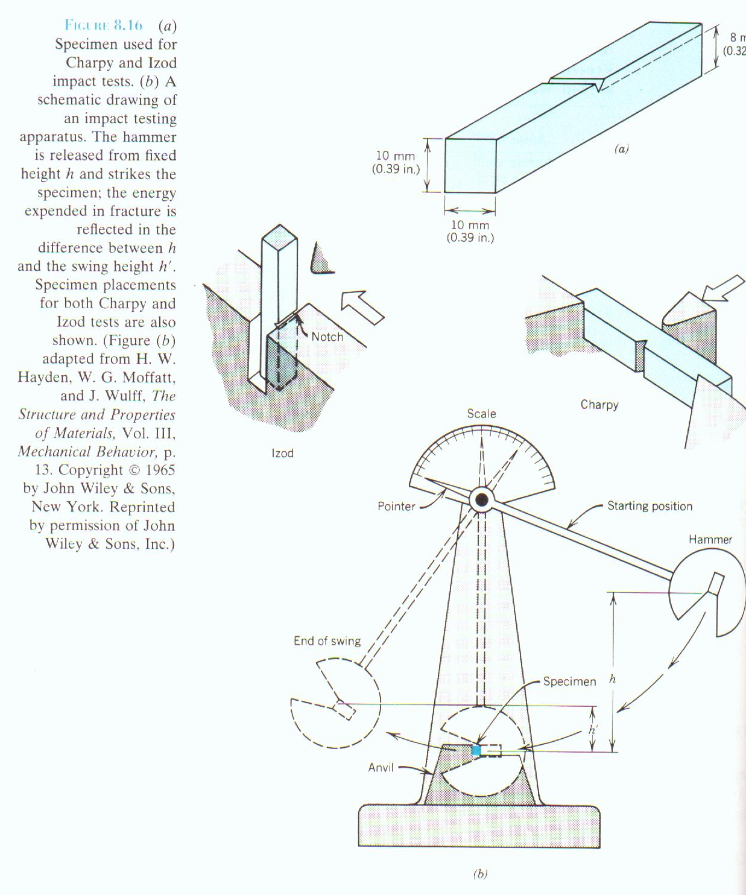
Figure 1 – Charpy Impact Testing Machine and Specimens
3.0 Data Analysis
Table 2 Specimen Conditions and Loading
Specimen |  | Symbol | Loading History
Steel AISI (1020) | 120 °C | S120 | Impact to Failure
Steel AISI (1020) | 60 °C | S60 | Impact to Failure
Steel AISI (1020) | 0 °C | S0 | Impact to Failure
Steel AISI (1020) | -60 °C | S60- | Impact to Failure
Steel AISI (1020) | -190 °C | S190- | Impact to Failure
Aluminum (6061-T6) | 120 °C | A120 | Impact to Failure
Aluminum (6061-T6) | 60 °C | A60 | Impact to Failure
Aluminum (6061-T6) | 0 °C | A0 | Impact to Failure
Aluminum (6061-T6) | -190 °C | A190- | Impact to Failure

- Obtained Data – explain how you got your data and what it means.
Date:
Testing Information:
Group No. and Names:
Notes:
Specimen | Temperature | Energy Absorbed (J)
S120 | 120 °C
S60 | 60 °C
S0 | 0 °C
S60- | -60 °C
S190- | -190 °C
A120 | 120 °C
A60 | 60 °C
A0 | 0 °C
A190- | -190 °C
- Plots
- Make a plot of absorbed energy versus test temperature for steel and aluminum. Discuss.
- Also make a plot of relative ductility versus temperature.
- Indicate transition temperature zone (Ductile to brittle zone) and upper and lower shelf energies.
- Concluding Remarks
- Discuss upper and lower shelf energies and well as ductility to brittle zones for each steel and aluminum.
- Include any sources of errors you feel are important.
Notes for This Lab!
- The impact tester looks and is dangerous. These tests must always be carried out under supervision of a laboratory technician and/or TA demonstrator.
- The temperatures at the root of the notch begins to change as soon as the sample is removed from the heating or cooling medium. The ASTM standard for the Charpy impact test requires that the delay time in transferring the specimen and performing the test must be less than 5 seconds.
- Examine all fractured surfaces and comment on your observations. Assess the amount of ductile and brittle fracture for each specimen.

