Civ E 265 Materials
Mid-Tem Exam Fall 2004 Solutions

- General

- a) What is the difference between an element, a compound, and a molecule? [4]
An Element is a “pure” substance composed of like atoms and appears on the periodic table (e.g. Au, Al, H). Elements are usually further organized into compounds: substances made of the union of two or more elements in definite proportion by weight. For example, water is a compound of hydrogen and oxygen, and salt is a compound of sodium and chloride. Two or more atoms, of the same or different elements, form molecules when they are held together with strong primary bonds. Therefore, nitrogen gas, which exists as N2, is a molecule but not a compound, and water is a molecule and a compound.

  - What is a polymer? [2]
A solid, non metallic (normally organic) compound of high molecular weight. The structure is composed of small repeating units (mers).

- List the three more classifications of material types. [3]
- Polymers
- Ceramics
- Composites

- List the four most common types of bonding in order of strength (highest to lowest)? [5]
      - Covalent
      - Metallic
      - Ionic
      - Van der Waals Bonds

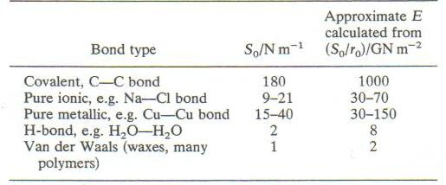

- List four of the most important classes of physical properties used to select materials for engineering applications? [4]
- Mechanical
- Optical
- Thermal
- Magnetic

- a) Give an example of a situation in which it would make sense to use concrete for civil engineering use rather than steel? [3]
- Compression Structures (Bridge Piers, Abutments)
- Mass Structures (Dams, Footings & Foundations – Where weight is a key consideration)
- Sidewalks, Highways, Floors (Where cost is a key consideration)

  - Give an example of a situation in which it would make sense to use wood for a civil engineering use rather than concrete. [3]
- Constructing a Residence (Framing), Desk. Wood is excellent for when you need a cost effective, light weight and easy to work with material.

- Sketch neat plots if stress versus strain for a material that is [6]
  - linear elastic
  - non-linear elastic
  - elasto-plastic

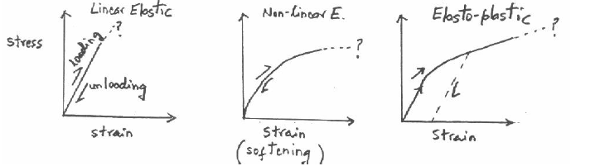

7. a) Define ductility, toughness, and resilience. [6]
Ductility: The ability of a material to deform plastically without fracturing,
Toughness: The area under the stress-strain curve up to fracture is a measure of the energy absorbed per unit volume of material.
Resilience: The tendency of a material to return to its original shape after the removal of a stress that has produced elastic strain.
b) Why is ductility a desirable property for a bridge? [2]
A ductile bridge allows for a large displacement before failure as compare with a non-ductile (brittle) material failure. Ductile failures give warning signs before failure as compared with brittle failures which are sudden failures.

c) Sketch a neat plot of both the expected probability distribution of the failure stress of a material, and the probability distribution of the applied stress. Identify the probability of failure on the sketch. [4]
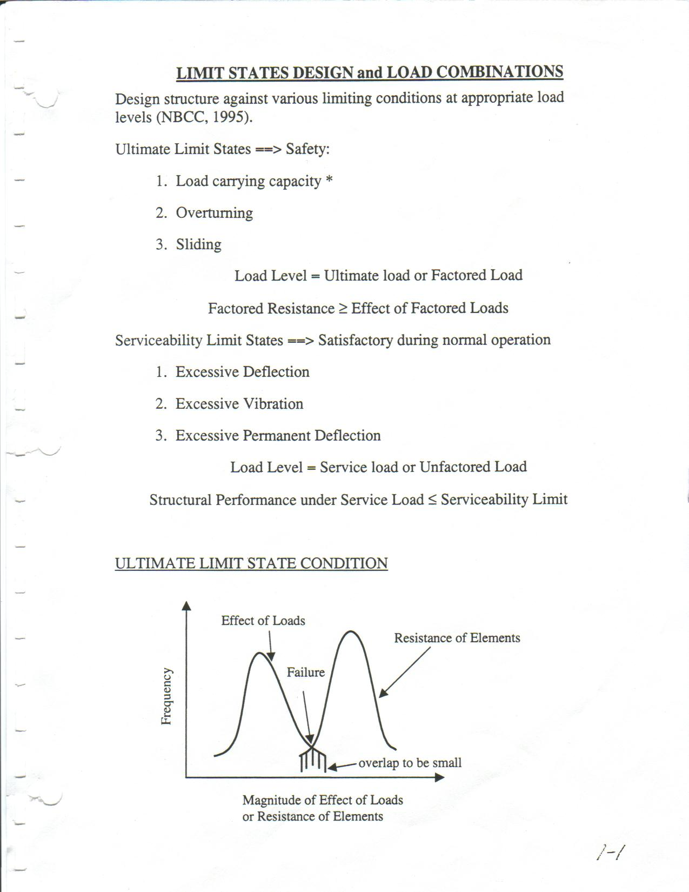
  - Define the term safety factor as used in engineering. [2]
$\text{SafetyFactor}=\frac{σ_{\text{Failure}}}{σ_{\text{Applied}}}$

- Metals

8. a) What makes steel, steel and not iron? [2]
The differences of ferrous alloys are based on carbon content, there are three types: iron, steel, and cast iron. Commercially pure iron contains less than 0.008 wt% C, and, from the phase diagram, is composed almost exclusively of the ferrite phase at room temperature. The iron-carbon alloy that contain between 0.008 and 2.14 wt% C are classified as steels. In most steels the microstructure consists of both  and Fe₃C phases.

b) How is steel different than cast iron? [2]
Cast irons are classified as ferrous alloys that contain between 2.14 and 6.7 wt% C.
c) What was the name of the important apparatus invented to convert pig iron to steel? [2]
Bessemer

9. a) Define a “dislocation”. [2]
A dislocation is a linear or one-dimensional defect in a metallic crystal structure around which some of the atoms are misaligned, including edge dislocation, screw dislocation, mixed dislocation.

b) Why are dislocations important to the mechanical operations? [2]
Dislocations are involved in the plastic deformation of crystalline materials. On a microscopic level, plastic deformation corresponds to the motion of dislocations in response to an externally applied shear stress; a process termed “slip”.

Since the ease with which a material is capable of plastic deformation is a function of dislocation mobility, restricting dislocation motion increases hardness and strength. On the basis of this principle, three different strengthening mechanisms are introduced such as strengthening by grain size reduction, solid-solution strengthening and strain hardening. The microstructural and mechanical characteristics of a plastically deformed metal specimen may be restored to their predeformed states by an appropriate heat treatment, during with recovery, recrystallizing and grain growth processes are allowed to occur.

- List four distinct types of metal formation operations. [4]

- Forging – mechanically working or deforming a single piece of a normally hot metal
- Rolling – Passing a piece of metal between two rolls
- Extrusion – A bar is forced through a die orifice by a compressive force
- Drawing – Pulling of a metal piece through a die having a tapered bore by tensile force

11.
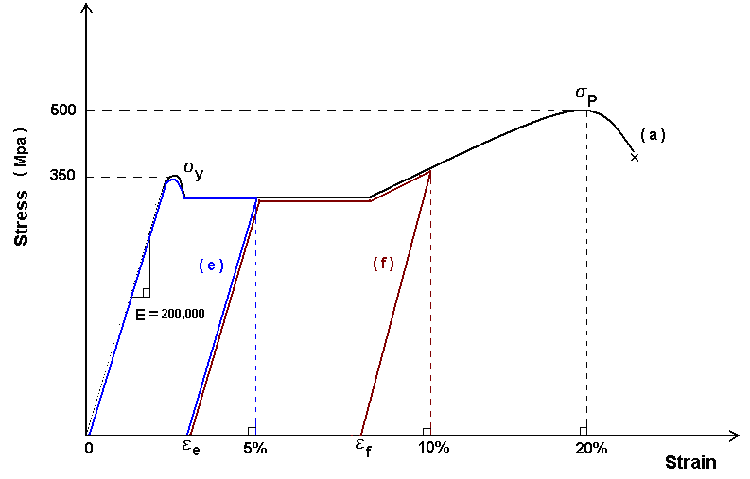

a) On a ½ page plot in your answer book plot a tensile stress strain curve for a low-carbon steel sample from zero strain to failure. Before the test, you heat the specimen to 800 Celsius for some time, and air cool it. The modulus of elasticity is 200 000 MPa, the yield stress is 350 MPa, and the peak stress just before failure is 500 MPa at a strain of 20%.

The typical stress-strain curve for a low-carbon steel sample is showed as black line in upper figure.

b) What is occurring within the structure of the steel that defines the modulus of elasticity?

On an atomic scale, macroscopic elastic strain is manifested as small changes in the interatomic spacing and the stretching of interatomic bonds. The crystals are being stretched apart and the individual atoms that makes up the crystals structure are being pulled further away from each other, but no bonds or grains are broken and weakening and no dislocations are slipping, and if the stress is released everything will return to its prior location.

As a consequence, the magnitude of the modules of elasticity is a measure of the resistance to separation of adjacent atoms, that is, the interatomic bonding forces.

c) What is occurring within the structure of the steel just after the yield point for the first few percent strain?

From an atomic perspective, plastic deformation corresponds to the breaking of bonds with original atom neighbors and then reforming bonds with new neighbors as large numbers of atoms or molecules move relative to one another; upon removal of the stress they do not return to their original positions. For crystalline deformation is accomplished by means of a process called slip which involves the motion of dislocations. So, just after the yield point, the first dislocations are moving, which result in permanent change in strain.

d) What happens to the stiffness (and what is occurring within the structure of the steel) just before failure (that is near the 20% failure strain)?

The stiffness increases just before failure because of strain hardening which is caused by the general “ locking up” or entanglement of the dislocations on irregularities or impurities in the crystal structures as well as the completion of dislocation migration, etc.

Dislocations tend to all be stopped and gather around crystal boundary and other imperfections. When no more dislocations can occur, then the specimen begins to distort (necking) just before total failure.

e) Plot the stress-strain curve (on the same plot as above) if you loaded the specimen to 5% strain and then unloaded it .

See the plot (e) in upper figure.

f) Plot the curve if you were to reload the specimen after e) to 10% strain.

See the plot (f) in upper figure.

g) If you now heated the specimen to 800 Celsius, held this temperature for 1 hour, and then air cooled it as before, describe in words what the stress strain curve would look like if you were to plot it.

The specimen experienced a fill annealing process, which is a heat treatment that is used to negate the effects of cold work, that is, to soften and increase the ductility of a previously strain-hardened metal. Since the sample, before testing in part a) was heated to 800 C and cooled, the stress-strain curve should be exactly the same as original one, say, plot (a) in upper figure.

